Llanmaes Flood Alleviation Scheme
Filippo Scimone

Rev No 2.0

Date

Version No | Prepared By | Checked By | Approved | Date
1.0 | Filippo Scimone | Anna Minchinton | Richard Derrick | 25 November 2021
2.0 | Filippo Scimone | Anna Minchinton | Richard Derrick | 7 March 2022

Contents
1 Llanmaes Flood Alleviation Scheme 4
1.1 Review limitation 4
1.2 Model Background 4
2 Model Review 4
2.1 General / Data Management 4
2.2 Hydrology Review 5
2.3 Modelling Software 5
2.4 Model Control Files 5
2.4.1 Review of *.ecf Files 6
2.4.2 Review of *.tcf Files 6
2.4.3 Review of *.tbc Files 7
2.4.4 Review of *.tgc files 8
2.5 Model Construction – Review of GIS Layers 11
2.5.1 Baseline Model GIS Layers 11
2.5.2 GIS Layer Review 14
2.6 Model Stability and Error Messages 19
2.6.1 TLF Summary 19
3 Results Review 21
3.1 Baseline Results 21
3.2 Proposed Results 21
3.3 Third Party Impact 22
4 Conclusions and Recommendations 24

Llanmaes Flood Alleviation Scheme

Review limitation
Natural Resources Wales (NRW) has not undertaken a full assessment of the fitness for purpose of the modelling and can accept no liability for any errors or inadequacies in the model, which remain the sole responsibility of the third-party consultant who developed the model.
Therefore, this is NOT a model Quality Assurance (QA) which will be done by the consultant prior to supplying the model to NRW.
The last model review done by NRW was December 2018 and this document must be read in conjunction with this review.
A model review was completed in November 2021 and version 1 of this report was supplied to AECOM for their consideration. Discussion have taken place between, VoG, AECOM and NRW, and a way forward was agreed for changes to the hydraulic model be done to ensure it meets the requirements of TAN15 and reliable model outputs. Text within the report will be Italics and in light blue to show any additional comments following the receipt of the updated model in February 2022.

Model Background
The Vale of Glamorgan Council (VoG) over many years (initial study circa in 2004) has been investigating a possible solution to reduce the flood risk in the village of Llanmaes. Llanmaes is to the east of the Llanmaes Brook and northeast of Boverton where there has been a scheme to reduce the flood risk within Boverton by replacement of a culvert. Historically, Llanmaes Village has regularly had flood events due to surface water runoff from the fields with the runoff flowing along roads and footpaths within Llanmaes Village.
Within Llanmaes Village there is an unnamed watercourse which has been modified to allow development within the village. This conveys drainage from the land from the northeast through the village then out to the southwest into Llanmaes Brook.
NRW has stated that any reduction of flood risk at Llanmaes Village must not increase flow downstream into Boverton, hence it is a requirement that the flood risk reduces or maintains the current flood risk.

Model Review
The model has previously undergone reviews by NRW, and the last review was completed in December 2018. This document will review comments made in that previous report and any possible issues which are discovered during this review. The reviewer has endeavoured to have sections in the report to follow the previous review.
The model has previously undergone several reviews by NRW with the last one being in November 2021. This review focuses on the improvements made within the February 2022 version of the model.

General / Data Management
The data supplied folder structure is shown in Figure 1. The data has not been supplied in the folder structure as model has been run, although it is easier to identify the scenarios runs, as it has been supplied it does run the risk of files being copied more than once. Although this makes the data easy to read it does mean we cannot open the data simply within MapInfo Pro or QGIS software.
The reviewer has reorganised the data to aid the reviewing process.
Llanmaes Flood Alleviation Scheme (FAS) Hydraulic Model Report has been supplied. A model log has also been supplied, this provides information on the model build and files used within the final model runs. It appears not to include all information relating to file name changes that have been supplied to NRW for this final review.
We note that the method employed in naming files may lead to confusion, with some files not having the version number at the end of the name e.g. “tbc” and “tgc” files. Other files using similar name’s structure although arranged differently e.g. like the cross-section files L_FAS_DD_010a.csv and L_FAS_010_DD.csv. This can lead to confusion by the reviewer and possibly the modeller.
NRW recommend that redundant/superseded files are excluded from the data supply this aids the model reviewer as they would then only have files that apply to the reports supplied.

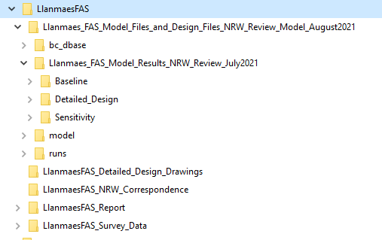
Figure 1 Folder Structure Data Supplied
Data supplied in more appropriate folder structure, a log spreadsheet and technical note has been supplied in a format as agreed with AECOM.

Hydrology Review
The hydrology used is from a previous study for the St. Athan Northern Access Road (NAR) which has previously been accepted by NRW. The hydraulic modelling report (MUR) states that the 1% Annual Exceedance Probability (AEP) rainfall has been uplifted by both 30% and 75% to account for climate change (CC), both have been supplied on this occasion. We note that the 0.1% plus climate change has not been included, this is now a requirement of the new TAN 15 and hence will be required when this comes into force.
There has been a delay in the roll out of the updated TAN15 and currently 0.1% AEP plus climate change is not a requirement at time of writing this model review report.

Modelling Software
The hydraulic software used is TUFLOW Classic version 2020-10-AA-iDP which was the current version at the time the simulations were run.
There has been no change in the software version that is used, this is acceptable to ensure any changes relate to changes in the model construction and not due to software improvements.

Model Control Files
The modeller has not simplified the number of control file by combining “ecf” and “tcf” files. Nor have the “tgc” and “tbc” been simplified by create a single “tgc” and “tbc”, hence there are 26 control files in all. Full use of event and scenario controls have not been employed to help in the reduction in the number of files and no use of “If Else” statement. A list of the control files supplied are shown in Table 1, with the highlighted control files being the focus of this review.
Table 1 TUFLOW control file list
1D Domain control file | 2D Domain control file
LlanFAS_BL_~s1~_~e1~_060_S_Bov.ecf | LlanFAS_BL_~s1~_~e1~_060_S_Bov.tcf
LlanFAS_BL_~s1~_~e1~_070.ecf | LlanFAS_BL_~s1~_~e1~_070.tcf
LlanFAS_BL_~s1~_~e1~_070_S_40pcPR.ecf | LlanFAS_BL_~s1~_~e1~_070_S_40pcPR.tcf
LlanFAS_BL_~s1~_~e1~_070_S_50pcPR.ecf | LlanFAS_BL_~s1~_~e1~_070_S_50pcPR.tcf
LlanFAS_DD_~s1~_~e1~_068_S_Bov.ecf | LlanFAS_DD_~s1~_~e1~_068_S_Bov.tcf
LlanFAS_DD_~s1~_~e1~_071.ecf | LlanFAS_DD_~s1~_~e1~_071.tcf
LlanFAS_DD_~s1~_~e1~_071_S_40pcPR.ecf | LlanFAS_DD_~s1~_~e1~_071_S_40pcPR.tcf
LlanFAS_DD_~s1~_~e1~_071_S_50pcPR.ecf | LlanFAS_DD_~s1~_~e1~_071_S_50pcPR.tcf
LlanFAS_DD_~s1~_~e1~_071_S_Blockage.ecf | LlanFAS_DD_~s1~_~e1~_071_S_Blockage.tcf

We note that the file names for the control files have been altered from the previous model supplied. This appears to have occurred in early 2019 when naming convention was altered.
We note the following use in the naming convention:
- File names with LlanFAS_BL* – Baseline Revision with 2020 Survey.
- File names with LlanFAS_DD* – Detailed Design Model.
- File names with *_S_Bov* – Sensitivity run includes Boverton Brook.
- File names LlanFAS_BL_~s1~_~e1~_070.* and LlanFAS_DD_~s1~_~e1~_071.* – Baseline for Planning Submission simulation.
- File names with *xxpcPR* – Sensitivity increased percentage runoff by “xx” percent.
- Filenames ending with *Blockage – 100% Blockage of all upstream storage bunds outfalls.

By the fact there are numerous control files we have noted that descriptions between control files for the same GIS layer are different, if the files where combined these descriptions would be easier to follow as these are all in one place.
We strongly recommend the modeller considers combining “ecf” and the “tcf” to create a single “ecf” and “tcf” for all model runs. Further it is possible in reducing the number of “tgc” and “tbc” with the use of “If Else” statement and better use of the event and scenario options. This will reduce the likelihood of errors between control files and avoid descriptions being different between files and hence leading to an easier QA or model review to be undertaken.
The following are the control files used for the model supplied. “BL” are baseline simulations and “DD” are the design simulations.
Review Table 1 TUFLOW control file for 2022 model
Baseline | Proposed
LlanFAS_BL_~s1~_~e1~_074.tcf | LlanFAS_DD_~s1~_~e1~_075.tcf
LlanFAS_BL_~s1~_~e1~_074_S_Bov.tcf | LlanFAS_DD_~s1~_~e1~_075_S_Bov.tcf
LlanFAS_BL_~s1~_~e1~_074_S_FSA50pc.tcf | LlanFAS_DD_~s1~_~e1~_075_S_FSA50pc.tcf
LlanFAS_BL_~s1~_~e1~_074_S_FSA100pc.tcf | LlanFAS_DD_~s1~_~e1~_075_S_FSA100pc.tcf

Review of *.ecf Files
There are no *.ecf as these have been combined with the *.tcf files.
For the “ecf” files we have only looked at the differences between the baseline and proposed scenarios and note the following:
- 1d_nwke_LLANFAS_042 is replaced by 1d_nwke_LLANFAS_DD_057
- 1d_nwke_LLANFAS_DD_USStorage_Drainage_068 is added which is part of the final proposed design.
- 1d_xs_LLANFAS_042 is replaced by 1d_xs_LLANFAS_DD_057
- 1d_WLL_LLANFAS_035 replaced by 1d_WLL_LLANFAS_DD_058

Review of *.tcf Files
No checks have been done for this review, section 5 Appendix A has the details as supplied by AECOM for details on the changes.
For the “tcf” files we have only looked at the differences between the baseline and proposed scenarios and note the following:
- LlanFAS_BL_2m_070.tgc replaced by LlanFAS_DD_2m_071.tgc
- LlanFAS_042.tbc replaced by LlanFAS_DD_071.tbc
- Added files 2d_po_LlanFAS_065 and 2d_po_LlanFAS_066_Region

Review of *.tbc Files
No checks have been done for this review, section 5 Appendix A has the details as supplied by AECOM for details on the changes.
The following files see Table 2, are employed in the latest version if the model. The naming convention has been altered since the last review.
Table 2 Tuflow 2d topography and boundary control files
File Name |  | Description in Control file
LlanFAS_BL_2m_060_S_Bov.tgc | LlanFAS_042_S_Bov.tbc | Approved NRW Pluvial Model including NAR Scheme. Same as StA_Com_044
LlanFAS_BL_2m_070.tgc | LlanFAS_070.tbc | BASELINE - Llanmaes FAS.tbc
LlanFAS_DD_2m_067_S_Bov.tgc | LlanFAS_DD_066_S_Bov.tbc | Approved NRW Pluvial Model including NAR Scheme. Same as StA_Com_044
LlanFAS_DD_2m_071.tgc | LlanFAS_DD_071.tbc | DETAILED DESIGN - Llanmaes FAS.tbc

LlanFAS_070.tbc Compared with LlanFAS_042_S_Bov.tbc
No checks have been done for this review, section 5 Appendix A has the details as supplied by AECOM for details on the changes.
Sensitive runs compared with the baseline and uses the full catchment that was employed for the original design model and the following changes are noted:
- 2d_bc_LlanFAS_040 replaced by 2d_bc_LlanFAS_041,
- 2d_rf_LlanFAS_039 replaced by 2d_rf_LlanFAS_040.

LlanFAS_070.tbc Compared with LlanFAS_DD_071.tbc and LlanFAS_042_S_Bov.tbc Compared LlanFAS_DD_066_S_Bov.tbc

A comparison between the final design, baseline model, and the full St Athan NAR model (sensitivity version) has been undertaken.
- 2d_hxi_LlanFAS_035 replaced by 2d_hxi_LlanFAS_DD_057,
- New file 2d_sx_LLANFAS_DD_USStorage_Draiange_066 part of the new run off defences.

The reviewer has compared the 2d_hxi* GIS layers and has noted the following:
- The HX lines in the Village Green area are wider in design scenario than in the baseline, see Figure 2, pink lines show proposed data used in model.
- The HX lines appears to show a bridge in baseline that was present, it is no longer in the model although HX lines have not been added back on left or right bank of the watercourse channel, see Figure 2.

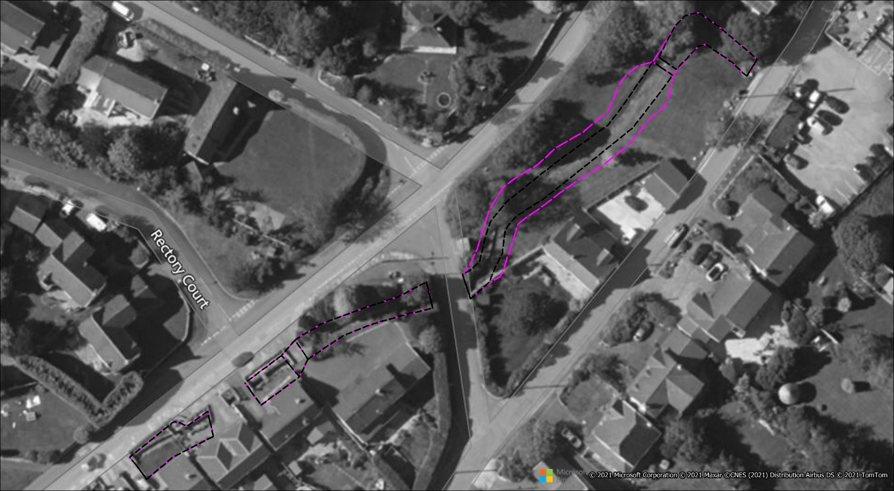
Contains OS data © Crown copyright and database right. All rights reserved. Ordnance Survey Licence number 100019741. Getmapping Plc and Bluesky International Limited 2021
Contains Natural Resources Wales data © 2021. All rights reserved.

Location of footbridge
Figure 2 1D/2D linkage and footbridge at Village Green
The removal of the bridge is documented in MUR in the Table 3-2 – Survey Ref: Sections 12/13. Justification for the removal of the bridge is acceptable although there appears to be no reasoning on why the HX lines have not been added.
We note that the HX line has been updated in the vicinity of the footbridge location with the redundant lines removed. In addition the channel width (defined by HX lines) between baseline and proposed are as in the previous model.
We note that the HX lines at this location have been widened for the proposed design scenario. From reviewing the model this is due to the proposed scheme widening the watercourse channel, although there does not appear to be reported directly in the MUR. The MUR should be updated.

Review of *.tgc files
No checks were made on the *.tgc files for this review, section 5 Appendix A has the details as supplied by AECOM for details on the changes.
The tgc files employed in the latest version of the model are listed in Table 2. There has been an increased number of files from the last review and the naming convention has been altered.

LlanFAS_BL_2m_070.tgc Compared with LlanFAS_BL_2m_060_S_Bov.tgc
A comparison has been undertaken to compare the baseline with the full catchment baseline that was employed for the original design NAR model and the following changes are noted:
- Grid extent increased to cover the original model extent.
- 2d_code_LlanFAS_039 replaced by 2d_code_LlanFAS_Bov_001.
- 2d_mat_BOV_manmade_070 replaced with 2d_mat_BOV_manmade_005.
- 2d_mat_LLANFAS_building_070 replaced with 2d_mat_LLANFAS_building_035

The data has had a limited review and it appears that the changes have been applied in the area where the proposed works are to be undertaken, this includes the 2d_mat_BOV_manmade layer data.
The reviewer notes that for the buildings GIS layer that buildings have changed shape or are no longer present between the baseline and sensitivity run. Although in many places this will have no impact, building shape changes within Llanmaes may have an impact to flow routing. Figure 3 shows an area to the northeast of the village where it is noted that the largest difference when comparing GIS layer 2d_mat_LLANFAS_building_070 with 2d_mat_LLANFAS_building_035, that two building in the GIS layers are significantly different. As this area is critical to flow path it requires a review and the latest GIS Layer building to be applied consistently for all model runs to ensure the same flood mechanism is applied to all scenarios.
It is noted that the Manning’s building GIS layer is now consistent for all simulations supplied and is now using 2d_mat_LLANFAS_building_070.
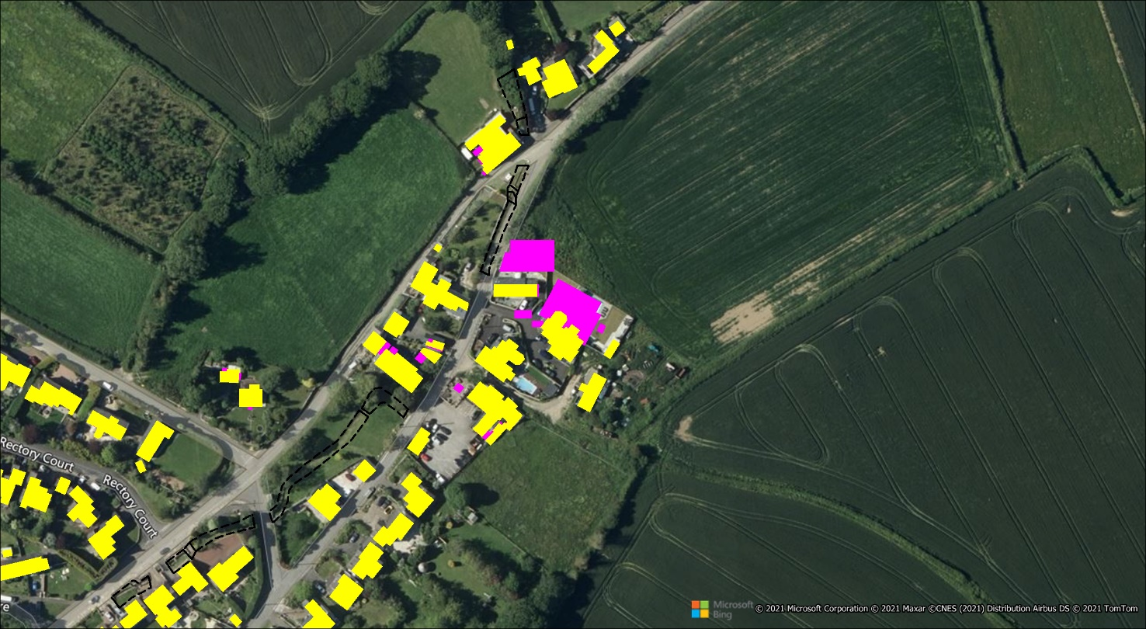
Contains OS data © Crown copyright and database right. All rights reserved. Ordnance Survey Licence number 100019741. Getmapping Plc and Bluesky International Limited 2021
Contains Natural Resources Wales data © 2021. All rights reserved.

Figure 3 Differences in building footprint - Yellow Proposed - Pink Baseline

LlanFAS_BL_2m_070 compared with LlanFAS_DD_2m_071 and LlanFAS_BL_2m_060_S_Bov.tgc compared with LlanFAS_DD_2m_067_S_Bov.tgc
We note the following differences between the files:
- 2d_code_LlanFAS_Channel_035 replaced by 2d_code_LlanFAS_DD_Channel_057.

The following are in baseline although not in or used for proposed scenarios:
- 2d_zln_LLANFAS_Banks_042
- 2d_zsh_LLANFAS_Swale_009
- 2d_zsh_LlanFAS_Highway_040

The following are only in proposed:
- 2d_zsh_LLANFAS_DD_USStorageArea_065
- 2d_zsh_LLANFAS_DD_Kerb_063
- 2d_zsh_LlanFAS_DD_Design_Patch_067

The following are topographical files used in proposed scenario runs:
- 20201027_west_rd_and_ditch_trim.txt
- DD_20201214_west_rd_069.txt
- DD_20210308_bund1_065.txt
- DD_20210308_bund2-3_065.txt
- DD_20210308_bund4_065.txt
- DD_20210308_ditch1_065.txt
- DD_20210318_ditch2_067.txt
- DD_20210318_ditch2_outfall_067.txt
- DD_20210308_overspill_065.txt
- DD_20201026_northrd_056.txt

The topographical modification data has been created outside TUFLOW so there are no check files. On reviewing the data these appear to have been applied correctly within the model, although it will be for the consultant to ensure these are correct as part of their QA process.

Model Boundary Database
The model boundary databases have been updated and details have been supplied by AECOM and details are in 5 Appendix A.
Table 3 shows the database used within the scenario’s modelled, however, seven were supplied. The review assumes the other four are redundant or superseded files. Table 4 lists which control file uses each database and a description of the databases directly from the control files.
On reviewing the database files in Table 3, it appears that there is no inflow entered in the database for the upstream section of Boverton Brook. This is incorrect and must be corrected.
A sensitivity test has been completed with flows applied within Boverton Brook for baseline and proposed to assess the impact downstream of the railway bridge for the 1.33% AEP flows. NRW has reviewed the model output immediately downstream of the B4265 and note that stage and flow is lower than in the baseline over the whole simulations.
Table 3 Inflows databased utilised in model
Inflow database used in model
bc_dbase_LlanFAS_001.csv
bc_dbase_LlanFAS_042_S_40pcPR.csv
bc_dbase_LlanFAS_042_S_50pcPR.csv

Table 4 Inflow database with associated tcf control files
Control File | Database file | Description in Control File
LlanFAS_BL_~s1~_~e1~_060_S_Bov.tcf | bc_dbase_LlanFAS_001.csv | Approved NRW Pluvial Model including NAR Scheme. Same as bc_dbase_StA_Com_002. database that relates the names of boundary conditions within MapInfo tables to their data (e.g. hydrographs)
LlanFAS_BL_~s1~_~e1~_070.tcf | bc_dbase_LlanFAS_001.csv | BASELINE - Llanmaes FAS. Same as ST ATHAN NAR MODEL bc_dbase_StA_Com_002.
LlanFAS_BL_~s1~_~e1~_070_S_40pcPR.tcf | bc_dbase_LlanFAS_042_S_40pcPR.csv | SENSITIVITY - 40% Runoff Coefficient
LlanFAS_BL_~s1~_~e1~_070_S_50pcPR.tcf | bc_dbase_LlanFAS_042_S_50pcPR.csv | SENSITIVITY - 50% Runoff Coefficient
LlanFAS_DD_~s1~_~e1~_068_S_Bov.tcf | bc_dbase_LlanFAS_001.csv | Approved NRW Pluvial Model including NAR Scheme. Same as bc_dbase_StA_Com_002. database that relates the names of boundary conditions within MapInfo tables to their data (e.g. hydrographs)
LlanFAS_DD_~s1~_~e1~_071.tcf | bc_dbase_LlanFAS_001.csv | BASELINE - Llanmaes FAS. Same as ST ATHAN NAR MODEL bc_dbase_StA_Com_002.
LlanFAS_DD_~s1~_~e1~_071_S_40pcPR.tcf | bc_dbase_LlanFAS_042_S_40pcPR.csv | SENSITIVITY - 40% Runoff Coefficient
LlanFAS_DD_~s1~_~e1~_071_S_50pcPR.tcf | bc_dbase_LlanFAS_042_S_50pcPR.csv | SENSITIVITY - 50% Runoff Coefficient
LlanFAS_DD_~s1~_~e1~_071_S_Blockage.tcf | bc_dbase_LlanFAS_001.csv | BASELINE - Llanmaes FAS. Same as ST ATHAN NAR MODEL bc_dbase_StA_Com_002.

Model Construction – Review of GIS Layers
The model is based upon the original licenced NRW Boverton model which has been heavily modified. Originally for the St. Athan Northern Access Road (NAR) and has had several revisions since that time to develop the Llanmaes FAS.

Baseline Model GIS Layers
There are more than a hundred GIS Layers which can lead to confusion when updating, Quality Assuring or a review of the model. Table 1 provides a list of GIS layers used with the model and which version are employed for different scenarios.
Table 5 GIS Layers Used in Model
GIS Layer | Baseline | Proposed | Planning | Blockage
1d_bc_StA_Com_001 | ü | ü | ü | ü
1d_bg_BOV_012 | ü | ü | ü | ü
1d_cs_BOV_050 | ü | ü | ü | ü
1d_cs_LLANFAS_035 | ü | ü | ü | ü
1d_mh_LLANFAS_035 | ü | ü | ü | ü
1d_nwke_AFON_050 | ü | ü | ü | ü
1d_nwke_BOV_EXT_FLOOD_RELIEF_033 | ü | ü | ü | ü
1d_nwke_LLANFAS_042 | ü |  | ü
1d_nwke_LLANFAS_BOVE_042 | ü | ü |  | ü
1d_nwke_LLANFAS_DD_057 | ü | ü | ü | ü
1d_nwke_LLANFAS_DD_USStorage_Drainage_068 | ü | ü | ü | ü
1d_nwke_LLANFAS_DD_USStorage_Drainage_068_S_Blockage | ü | ü | ü | ü
1d_nwke_LLANFAS_Drainage_Ditch_042 |  | ü |  | ü
1d_nwke_LLANFAS_Frog_FRC_042 |  | ü
1d_nwke_LLANFAS_LlamaesBrook_035 |  |  |  | ü
1d_nwke_LLANFAS_Outfall_Culverts_035 | ü | ü | ü | ü
1d_nwke_LLANFAS_S_Bov_Culvert_042 | ü | ü | ü | ü
1d_nwke_StA_Com_BOVE_EXT_029 | ü | ü | ü | ü
1d_nwke_StA_Com_BOVUS_Bund_034 | ü | ü | ü | ü
1d_nwke_StA_Com_Nant_FRC_041 | ü | ü | ü | ü
1d_nwke_StA_Com_Underpass_037 | ü | ü | ü | ü
1d_nwke_UNKN_050 | ü | ü | ü | ü
1d_WLL_LLANFAS_035 | ü | ü | ü | ü
1d_WLL_LlanFAS_AFON_042 | ü | ü | ü | ü
1d_WLL_LlanFAS_BOVE_042 | ü | ü | ü | ü
1d_WLL_LLANFAS_BOVE_EXT_042 | ü |  | ü
1d_WLL_LLANFAS_DD_058 | ü | ü | ü | ü
1d_WLL_LLANFAS_Drainage_Ditch_042 | ü | ü | ü | ü
1d_WLL_LLANFAS_LLAN_042 | ü | ü | ü | ü
1d_xs_AFON_002 | ü | ü | ü | ü
1d_xs_LLANFAS_042 |  | ü |  | ü
1d_xs_LLANFAS_BOVE_011 | ü | ü | ü | ü
1d_xs_LLANFAS_DD_057 | ü | ü | ü | ü
1d_xs_LLANFAS_Drainage_Ditches_040 | ü | ü | ü | ü
1d_xs_LLANFAS_LLAN_041 | ü | ü | ü | ü
1d_xs_StA_Com_BOVE_Ext_018 | ü |  | ü
2d_bc_BOV_004 | ü | ü | ü | ü
2d_bc_inflow_StA_Com_001 |  | ü |  | ü
2d_bc_LlanFAS_040 | ü | ü | ü | ü
2d_code_LlanFAS_039 | ü | ü | ü | ü
2d_code_LlanFAS_Channel_035 | ü | ü | ü | ü
2d_code_LlanFAS_DD_Channel_057 | ü | ü | ü | ü
2d_hxi_LlanFAS_035 | ü | ü | ü | ü
2d_hxi_LlanFAS_DD_057 | ü | ü | ü | ü
2d_hxi_LLANFAS_LLAN_011 | ü | ü | ü | ü
2d_hxi_StA_Com_BOV_EXT_029 | ü | ü | ü | ü
2d_hxi_StA_Com_Drainage_Ditch_032 | ü | ü | ü | ü
2d_loc_StA_Com_025 | ü |  | ü
2d_mat_BOV_manmade_070 | ü |  | ü
2d_mat_BOV_rail_005 |  | ü |  | ü
2d_mat_BOVE_EXT_stability_001 |  | ü |  | ü
2d_mat_LLANFAS_building_070 | ü | ü | ü | ü
2d_mat_LLANFAS_LlanStability_011 | ü | ü | ü | ü
2d_mat_LLANFAS_natural_035 | ü | ü | ü | ü
2d_mat_LLANFAS_road_035 | ü | ü | ü | ü
2d_mat_LLANFAS_roadside_035 | ü | ü | ü | ü
2d_mat_LLANFAS_scrub_035 | ü | ü | ü | ü
2d_mat_LLANFAS_Stability_006 | ü | ü | ü | ü
2d_mat_NAR_Dec_2016_010 | ü | ü | ü | ü
2d_mat_StA_Com_RainfallStab_041 | ü | ü | ü | ü
2d_mat_StA_Com_Weir_041 | ü | ü | ü | ü
2d_po_LlanFAS_065 | ü | ü | ü | ü
2d_po_LlanFAS_066_Region | ü | ü | ü | ü
2d_po_LlanFAS_070 | ü | ü | ü | ü
2d_rf_LlanFAS_039 | ü | ü | ü | ü
2d_sx_BOV_EXT_FLOOD_RELIEF_041 | ü | ü | ü | ü
2d_sx_BOV_EXT_Underpass_032 | ü | ü | ü | ü
2d_sx_LLANFAS_DD_USStorage_Draiange_066 | ü | ü | ü | ü
2d_sx_S_Bov_Cu_041 | ü | ü | ü | ü
2d_sx_StA_Com_BOVUS_Bund_031 | ü | ü | ü | ü
2d_sx_StA_Com_Nant_FRC_040 | ü | ü | ü | ü
2d_sx_StA_Com_Outfall_Culverts_023 |  | ü |  | ü
2d_zln_BOV_bridge_parapet_031 |  | ü |  | ü
2d_zln_BOV_gully_009 | ü | ü | ü | ü
2d_zln_DEF_LLAN_banks_015 | ü | ü | ü | ü
2d_zln_DEF_LLANFAS_BOV_banks_011 | ü | ü | ü | ü
2d_zln_DEF_UNKN_banks_003 | ü | ü | ü | ü
2d_zln_LLANFAS_Banks_042 | ü | ü |  | ü
2d_zln_LLANFAS_DD_Banks_048 | ü | ü | ü | ü
2d_zln_StA_Com_BOV_EXT_Banks_029 | ü | ü | ü | ü
2d_zsh_BOV_bridge_decks_012 | ü | ü | ü | ü
2d_zsh_BOV_EXT_flood_bund_025 | ü | ü | ü | ü
2d_zsh_BOV_EXT_FRC_Ditches_029 | ü | ü | ü | ü
2d_zsh_LlanFAS_BridgeDeck_042 | ü | ü | ü | ü
2d_zsh_LlanFAS_Buildings_Threshold_035 | ü | ü | ü | ü
2d_zsh_LlanFAS_DD_Design_Patch_067 | ü | ü | ü | ü
2d_zsh_LLANFAS_DD_Kerb_063 | ü | ü | ü | ü
2d_zsh_LLANFAS_DD_USStorageArea_065 | ü | ü | ü | ü
2d_zsh_LlanFAS_Ditch_Bank_040 | ü | ü | ü | ü
2d_zsh_LlanFAS_Highway_040 | ü | ü | ü | ü
2d_zsh_LlanFAS_lidar_fix_002 | ü | ü | ü | ü
2d_zsh_LLANFAS_LiDAR_Patch_039 | ü |  | ü
2d_zsh_LLANFAS_Swale_009 | ü | ü |  | ü
2d_zsh_LlanFAS_Topo_042 | ü | ü | ü | ü
2d_zsh_NAR_Dec_2016_010 | ü | ü | ü | ü
2d_zsh_StA_Com_BOV_Drainage_Topo_018 | ü | ü | ü | ü
2d_zsh_StA_Com_Drainage_Basin_012 | ü | ü | ü | ü
2d_zsh_StA_Com_Drainage_Ditches_043 | ü | ü | ü | ü
2d_zsh_StA_Com_flood_bund_Llan_023 | ü | ü | ü | ü
2d_zsh_StA_Com_Frog_Flowpath_022 |  | ü |  | ü
2d_zsh_StA_Com_Llan_Topo_032 |  | ü |  | ü
2d_zsh_StA_Com_S_Bov_Topo_043 |  | ü |  | ü
2d_zsh_StA_Com_US_BOV_Stor_031 | ü | ü | ü | ü
2d_ztin_BOV_EXT_flood_bund_weir_BOV_033 | ü | ü | ü | ü
2d_ztin_BOVE_EXT_US_WEIR_035 | ü | ü | ü | ü
2d_ztin_LLANFAS_flood_bund_weir_Llan_003 | ü | ü | ü | ü
2d_ztin_StA_Com_Agricultural_Underpass_032 | ü |  | ü

The reviewer has been unable to compare changes between previous model GIS layers and current model as the naming convention has changed.

GIS Layer Review
The report will where possible use comments from the Llanmaes FAS Review Rev No 2.0 14th December 2018, plus any additional new comments from relating to the latest supplied version of the model. As not all GIS layers exist or have been replaced by different layers the reviewer will attempt to ensure the appropriate comparison is done.

Boundary Files 1d_bc_StA_Com_001, 2d_bc_BOV_004, 2d_bc_inflow_StA_Com_001 and 2d_bc_LlanFAS_040
There has been no change to these layers from the previous review simply based on the file name. We note that 2d_bc_LlanFAS_040 has not been changed, see Figure 2, nor can we find a clarification within the reports on why it has not been amended as was recommended. The model must either be corrected, or justification provided on why it is not having any significant effect on the model results.
This has been corrected for the current simulations.
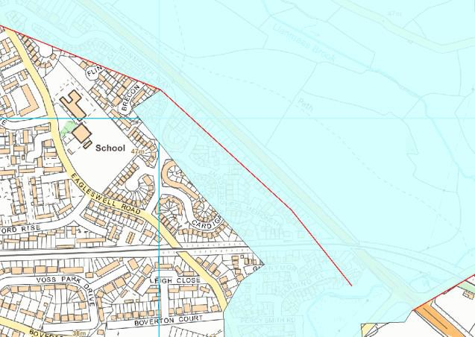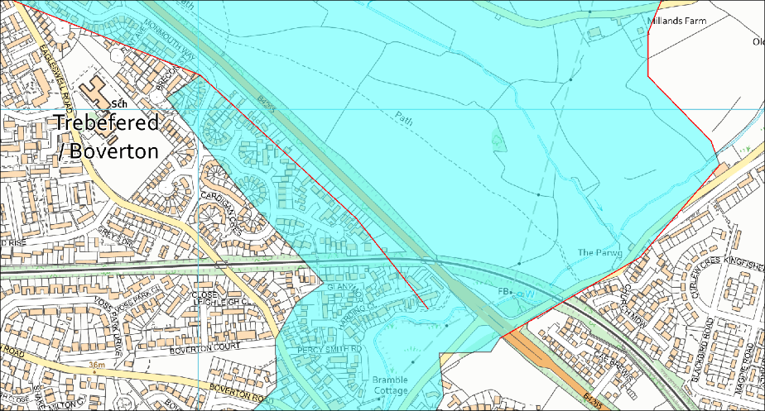
Contains OS data © Crown copyright and database right. All rights reserved. Ordnance Survey Licence number 100019741. Getmapping Plc and Bluesky International Limited 2021
Contains Natural Resources Wales data © 2021. All rights reserved.

Figure 4 Left-hand image previous review and right-hand image current review – no change in data

Bridge, Culverts and Weirs 1d_bg_BOV_012, 1d_cs_BOV_050 and 1d_cs_LLANFAS_035

It was agreed that as this is outside the area of interest and would not be amended.
We note the following comments from the previous review. There has been no update within these layers by the consultants and hence previous comments apply.
“The files have previously been reviewed with the exception of 1d_cs_LLANFAS_035. Two additional bridges have been added within this layer and one bridge HW reference has been re-named. In addition, all bridge structures have been updated from B type structure to BB type structures, with the exception of two bridges which are located downstream of the study area (1d_nwke_AFON_050). This review focuses on the model upstream of the B4265. As stated within the previous review, there is little need to the model to extend downstream of the B4265, it would aid in QA if the model was cut down, however, this will have no impact on the results.
NRW previous review recommended that “T” was assigned to the UCS attribute and “0” is assigned to “n_or_n_F”. It is noted that this has been adopted across the majority of the features, however this has not been applied consistently across all the layers used within the model.
It is noted that following the previous review form loss has been updated to 0.001, where required, with the exception of BOVE_0033BW, which has a form loss of 0.01. This structure is located downstream of the B4265; therefore, it is unlikely to affect the results within Llanmaes.”

1d_nwke* GIS Layer Review
We note that the following comments from the previous review have not been implemented in the model supplied:
- We note culvert BOVE_02_0042 (Cad drawing ID) is not within the model.
  - The model log provides information on omitted structure, this does not make clear reference to BOVE_02_0042. It has been confirmed that BOVE_02_0042 is included in the model as BOVE_02_0042C1 & BOVE_02_0042C2.
- NRW recommends that all fields relating to culvert losses are populated and all culverts are reviewed. It was agreed that as this is outside the area of interest and would not be amended.
- It is noted that fields relating to culvert losses have been updated however, in some cases a further review is needed for example, entry and exit losses have not been applied to the culverts within 1d_nwke_UNKN_050. – no change to losses applied to this layer therefore default values applied, we note an update have been done in 1d_nwke_BOV_EXT_FLOOD_RELIEF_072 GIS layer. Note that the software has not applied exit/entry losses where the value is null or zero.

The modeller must document the reasoning why BOVE_02_0042 being omitted and review the missing attributes for the entry and exit losses of all culverts ensure these are populated. – clarification provided in technical note.

1d_xs_* GIS Layer review
The reviewer notes that 1d_xs_StA_Com_Drainage_Ditches_040 has been renamed to 1d_xs_LLANFAS_Drainage_Ditches_040. Comparing the files, it appears to be identical and hence the reviewer assumes this is just a file rename. This does not appear to be noted within the log file.
The review notes a new cross sections file called 1d_xs_LLANFAS_DD_057 which the reviewer assumes replaces 1d_xs_LLANFAS_PreOpt5_LLAN_040.
As this GIS layer 1d_xs_LLANFAS_DD_057 provides the location of the new cross section and links the new profile for the Village Green the review has examined this data.
It is noted that for cross section for the proposed design LLANFAS_011_DD_Rev1.CSV replaces LLANFAS_011_Rev2.CSV. This appears to have lowered the right-hand bank ground elevation by approximately 0.1 metres. Which is assumed to tie into the reprofiling of the ground at this location.
We have compared the cross-section data applied to the model at the village green and the data supplied. We note that the data has been extracted from underlaying proposed topography as stated in the cross-section files (“Village Green Widened with assumed constant gradient from L_FAS_010 to L_FAS_011. Elevations extracted from DD 20201027_west_rd_and_ditch.txt”). This has raised concerns on whether this has been applied correctly, see Figure 5. Furthermore, the reviewer would have considered it more appropriate to use the raw design of the channel to derive the proposed cross sections rather than going via the asc.
- We note that for the L_FAS_DD_010c and L_FAS_DD_010d sections the channel bed is set at the same invert hence over approximately 20 meters hence there is no gradient within the channel.
- We note that between L_FAS_DD_010a and L_FAS_DD_010b the channel bed raises.
This has now been corrected.
It is noted from the previous review the following:
- We note cross-section Drainage_A6 is not connected to any 1d_nwk and has not been corrected from previous study work for NAR.
  - Cross-section Drainage_A6 remains within the model, it is not clear if any changes have been made in relation to this cross section as the cross section does not appear to be connected to any 1d_nwk. – this appears to have been correct

The above cross sections must be reviewed and amended with the correct topographical information or removed if not required.
NRW note that Drainage_A6 has now been placed onto a network GIS layer 1d_nwke_LLANFAS_Drainage_Ditch_042.
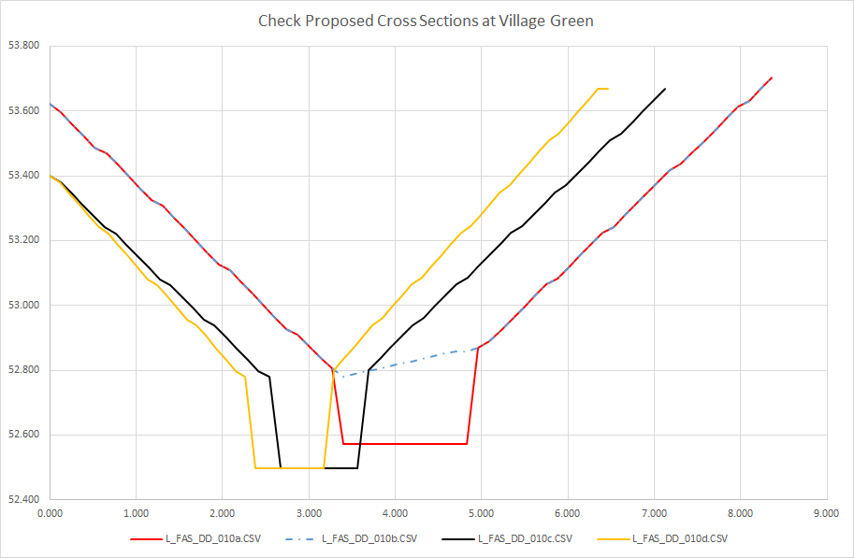
Figure 5 Check of proposed channel widening at Village Green

1d_WLL_* GIS Layer review
We note no changes from the previous model

2d_code* GIS layers review
We note the following:
- 2d_code_LlanFAS_039 activates the 2D code extent. – 2d_code_LlanFAS_072 has replaced the previous version and has corrected the boundary issue described in section 2.5.2.1.
- 2d_code_LlanFAS_Channel_035 deactivates the channel for baseline FAS model – 2d_code_LlanFAS_Channel_072 has replaced the previous version and has corrected to match HX lines corrected at The Green in Llanmaes.
- 2d_code_LlanFAS_DD_Channel_057 deactivates the channel for proposed FAS model.

These files either activates or deactivates areas within the 2D domain, we note that 2d_code_LlanFAS_DD_Channel_057 is new since the last review.

2d_hxi* GIS layers review
These layers provide linkage between the 1D and 2D domains of the model. These GIS layers may be used deactivation the 2D domain for the rivers and these have been employed this way within the model excluding Llanmaes Village which uses a 2d_code polygon.
We note that since the last review that 2d_hxi_LlanFAS_DD_057 is an additional GIS layer which is used to define the 1D/2D linkage for FAS within Llanmaes village.

2d_loc_stA_Com_025 GIS layer review
This file was present in the previous model supplied and appears to be correctly applied.

2d_MAT* GIS layers review
We note the previous review comments, and these recommendations still stand as there appears to have been no change.
“The 2d_mat layers are based on OS MasterMap® data. In addition to these three stability patches have been used, as recommended previously unless there is good justification, one combined stability patch layer would be sufficient.
It is noted that a few of the layers have been updated since the previous review. It is assumed that these have been updated to ensure the 2d_mat layers cover the full model domain. As it was noted within the previous review that the layers did not cover the full model domain”.
Following a review of the current model Manning’s layers it is noted that for the new proposed ditches and storage ponds the Manning’s have not been altered; the modeller should consider whether the values used are still appropriate. Reasoning on options selected must be documented within the MUR.
Manning’s values have been amended and reasoning provided within technical note.

2d_po_LlanFAS_065, 2d_po_LlanFAS_066_Region and 2d_po_LlanFAS_070 GIS layer review
These GIS layers have been used to extract 2D time series results in multiple locations around Llanmaes. It is noted 2d_po_LlanFAS_070 includes many PO lines which have a type of “H_QX_QV_Q_V_” applied, type “QV” attribute is not within the TUFLOW manual.
As stated in the previous review we assume that TUFLOW is currently ignoring this attribute, however we still require further clarification that the PO layer is capture the information the modeller intended and recommend that “QV” attribute is removed for clarity.
These have been updated and attributes corrected.

2d_rf_LlanFAS_039 GIS layer review
The reviewer notes the comments from the previous review, and these still stand for this review. The main issue is that there is still no flow within Boverton Brook at the upper reach.
This layer applies the inflow hyetograph to the model. This layer has been updated since the previous review. The layer appears to be correctly linking to the rainfall hyetographs within StA_Com_60min_002_0,3RC.csv. It is noted that the 1d inflows have not been provided within the bc_dbase folder and therefore have not been reviewed. Basic information on the derivation of the hyetograph have been provided within the modelling report. However, we would recommend additional information is provided on the derivation of the storm duration.
In addition, it is noted that Boverton Brook has no 1d inflow, the channel is located outside of the 2d_rf extent. Therefore, the channel is running dry. This is not correct and needs to be updated to ensure the flows can be correctly assessed at Boverton.
It is noted that the 1d and 2d domains are both starting dry at the start of the run. This has the potential to increase the amount of storage available within the model (for example the ponds at Frampton court are starting empty, which could affect the amount of water which will flow down Llanmaes Brook). We would recommend that sensitivity tests are undertaken to consider the antecedent conditions of the catchment, with consideration made to both the initial water levels as well as the percentage run-off (potential impact on hyetographs).
Sensitivity runs done with flow applied within Boverton Brook, and further information regarding the hyetographs has been included in the main model report (Appendix C).

2d_sx* GIS layers review
There is a total of seven 2d_sx layers which have been used with the model scenarios runs. The only one that appears to have been altered from the previous review is the proposed GIS Layer 2d_sx_LLANFAS_DD_USStorage_Draiange_066.
Note that comments from previous review remain.

2d_zln* GIS layers review
These GIS layers are applied to alter the underlying LIDAR topography of the 2D domain by lowering or raising the ground levels. There are currently eight zlns used in the current model scenarios runs. 2d_zln_LLANFAS_Banks_042 was previously updated, to remove redundant zpt which are not associated with a zline, it is noted that unconnected zpts are still present and have not been removed or zln extended to the zpts since the last review. This will need to be amended as previously recommended.
This has been corrected.

2d_zsh* GIS layers review
There are 23 zsh used to alter the underlying topography of the 2d domain. The number of layers used is large and can be streamline which will aid model QA and reviews.

2d_ztin* GIS Layers and ERSI II asc files review
These GIS layers alter the underlying topography of the 2d domain. In total there are four GIS layers which have been used within the model. As these have the same names from the previous review, therefore these files have not been checked within this review.
We note that the topography changes for the proposed scheme are now imported as “ERSI II asc” text files. These appear to have been imported correctly into the model to amend the topography. As this data is created externally to the hydraulic model it is not therefore possible to review if the data is correct prior to importing in the hydraulic model. However, we do note that an area in the Village Green may not have been correctly created and this is highlighted in Figure 6, this area will require reviewing and amended as necessary.
This has been amended and representation has been improved.

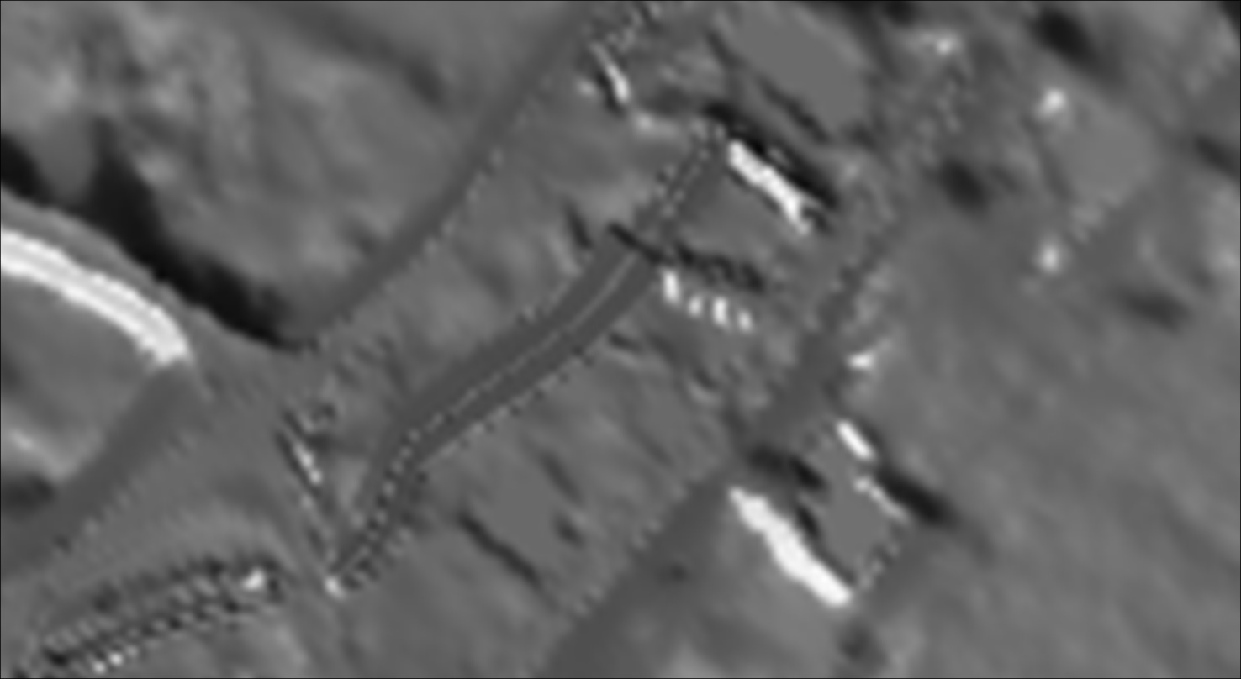
Contains OS data © Crown copyright and database right. All rights reserved. Ordnance Survey Licence number 100019741. Contains Natural Resources Wales data © 2021. All rights reserved.

Figure 6 Poorly created topography

Model Stability and Error Messages
It is important that all messages are reviewed prior to submitting the model to NRW and that these are covered within the MUR. Any instabilities are reduced or removed from the model where there is no technical justification for them.

TLF Summary
For the baseline and the detail design models we note the following:
- Mass balance is within ±1% with the maximum occurring at time zero.
- Classic 1D Negative Depths occurs for all simulation logs supplied and range from 14 to 26 apart from simulation LlanFAS_BL_DEF_Q0100+CC30_070_S_50pcPR which has a total of 264. For the simulations supplied range from 14 to 32, the impact of these is covered in the technical report.
- Classic 2d Negative Depths occur in eight simulations and range from 1 to a maximum of 6. For the simulations supplied range from 0 to 31, the impact of these is covered in the technical report.

Although a discussion and justification are provided with the MUR for the 1D negative depths, it is noted that it does not cover Classic 1D Negative Depths for the simulation that are reported in LlanFAS_BL_DEF_Q0100_070.tlf. Nor does it cover the low number of Classic 2d Negative Depths that are reported with the “tlf” files. This must be added to the MUR.
Table 6 has highlighted rows which are not in the MUR, special attention to “CHECK 1402 and WARNING 1313” is needed, as these are part of the FAS hence these must be reviewed and corrected to ensure the model is performing as was intended.
We note that the following CHECK 2077, CHECK 2078, WARNING 1253 and WARNING 2118 are not present in the new simulations supplied. CHECK 1402 and WARNING 1313 are covered within the technical report.
Table 6 Error message from all message logs
Message ID | Comments
CHECK 1037 | This occurs when centre cross section hasn’t been specified, the cross-section properties are interpolated from the upstream and downstream cross sections, hence modeller to ensure these are what was intended at this  location.
CHECK 1152 | A cross section has been found at the channel centre and not at end of channel this takes priority over end-section(s) and hence are being ignored.
CHECK 1284 | Connecting a 1d H boundary to 2d HX link, modeller to check this intended.
CHECK 1402 | More than one culvert connected but could not create manhole at Node: Bund1_FRC.2  Bund2_FRC.2  Bund3_FRC.2  Bund4_FRC.2
CHECK 2077 | Beginning of 3D line is dangling
CHECK 2078 | End of 3D HX/TIN/line breakline is dangling.
CHECK 2099 | Ignored repeat application of boundary to 2d cell, need to ensure that this is correct.
CHECK 2108 | 2D HX link applied more than once at cell.
CHECK 2118 | Lowered SX ZC Zpt by x.xx to 1d node bed level, need to ensure values are correct.
CHECK 2231 | No ZP points snapped to HX line. HX line not used to modify Zpts, NRW view is that Zln should be used to increase bank elevations to avoid this error.
CHECK 2370 | Ignoring coincident point, ensure results are as intended.
WARNING 1100 | The WARNING is issued where a 1d structure’s invert/bed lies below the bed of the upstream and/or downstream channel, modeller needs to check these values are correct.
WARNING 1253 | Unused 1d_ta line with attributes – check that it was intended to for cross section not to be used.
WARNING 1313 | No inlet culvert connected to Manhole “see below". Manhole not used/applied.  Bund1_FRC.2  Bund2_FRC.2  Bund3_FRC.2  Bund4_FRC.2
WARNING 1317 | WLL does not cross (2-point WLL only) or snap to 1d channel, modeller needs to correct although no impact on model results.
WARNING 1991 | Negative depth at Node
WARNING 2073 | NONE object ignored. Only Regions, Lines, Polylines & Multiple Polylines used.  TEXT object ignored. Only Regions, Lines, Polylines & Multiple Polylines used.
WARNING 2117 | Inactive 2D cell made active by 2D SX link.
WARNING 2118 | Lowered SX ZC Zpt by <change in 2C cell elevation> to 1D node bed level.
WARNING 2468 | Active cell has no active faces
WARNING 2991 | Negative U depth at xx or Negative V depth at xx

Results Review
As with the previous review this review has used results of the 1% AEP plus 30% CC. The results show flood depths which are greater than 0.05m as done in the previous review. By doing this it aids the representation of the surface water flow routes.

Baseline Results
Figure 7 shows the main flow pathways which follow tracks, roads and the watercourses.
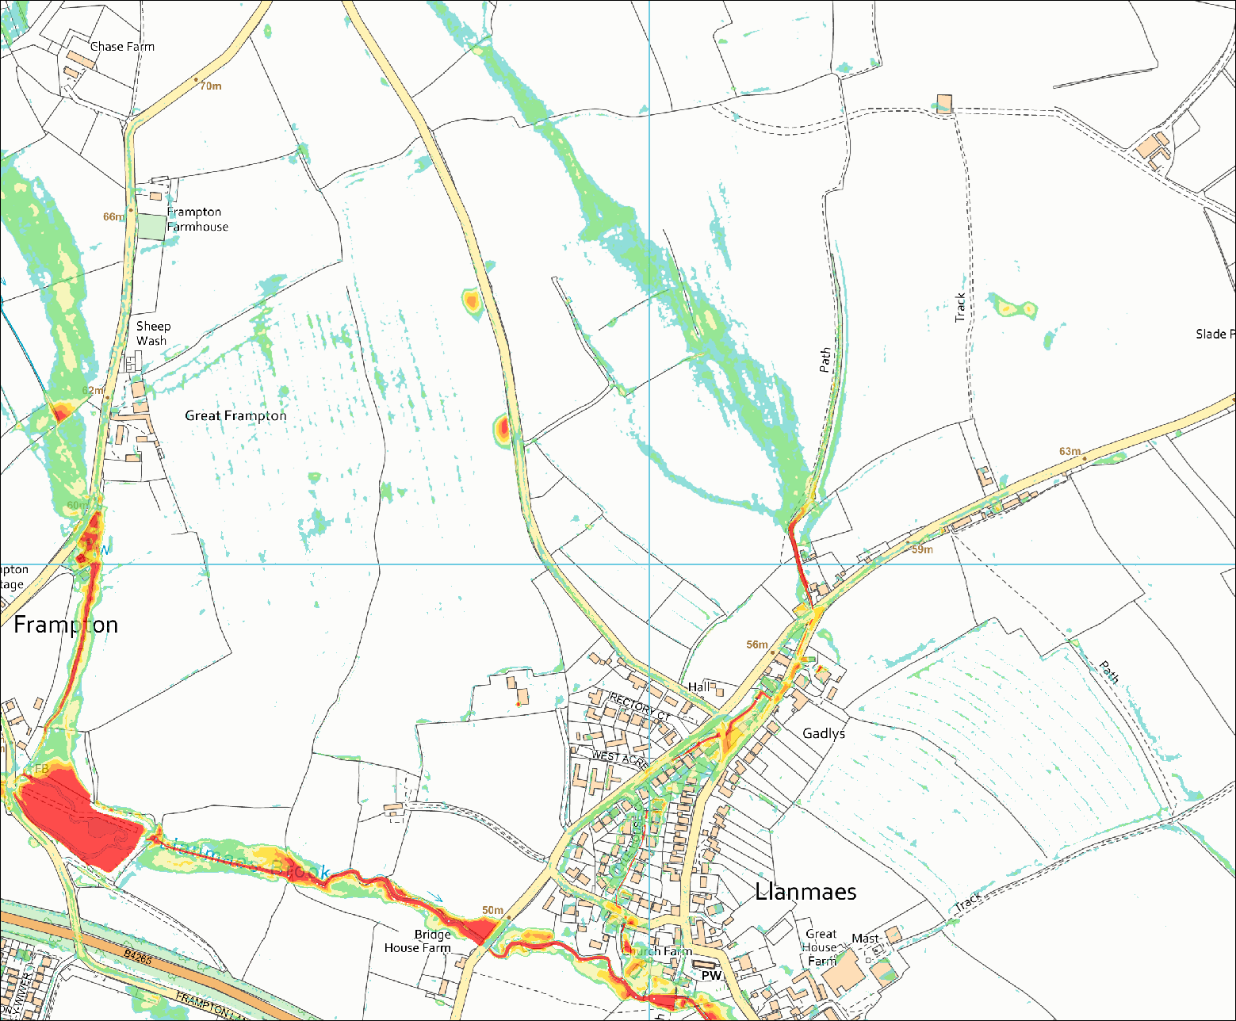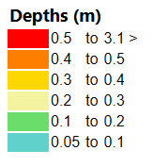
Contains OS data © Crown copyright and database right. All rights reserved. Ordnance Survey Licence number 100019741. Contains Natural Resources Wales data © 2021. All rights reserved.

Figure 7 Baseline Depth Results1% AEP + 30%CC

Proposed Results
Since the last model review there has been changes to the proposed flood mitigation. The features still include the four upstream flood storage areas, ground, and road reprofiling plus the removal of two flow constriction on Llanmaes Brook. Additional to these are new ditches with storage ponds have been added to the flood mitigation which are designed to reduce flow in to Llanmaes Village. These can be seen in Figure 8 which shows the impact of the mitigation with the reduction of flood risk through Llanmaes Village.
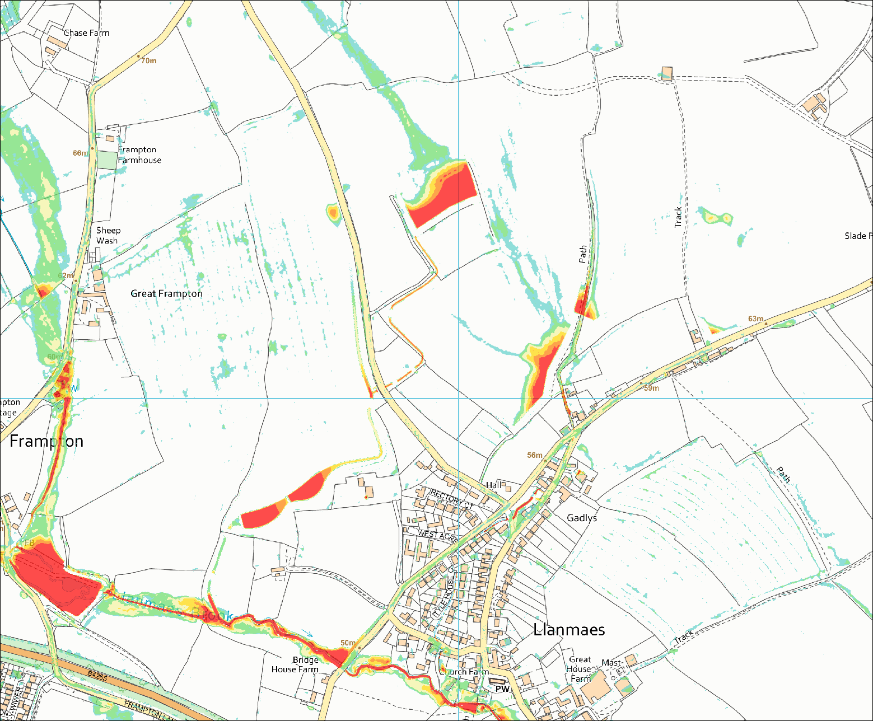
Contains OS data © Crown copyright and database right. All rights reserved. Ordnance Survey Licence number 100019741. Contains Natural Resources Wales data © 2021. All rights reserved.

Figure 8 Proposed Model Depth Results 1% AEP + 30%CC

Third Party Impact
The review only considered the 1% AEP + 30%CC results as shown in Figure 7 and Figure 8. Figure 9 shows a depth comparison between the final proposed FAS and baseline. The mitigation appears to have reduced in general the flood depths within Llanmaes. Although the mitigation has increase flood depths within the proposed storage ponds upstream of Llanmaes village, along the road/track which passes on the western side of Llanmaes (part of the design) and within the Village Green area which provides additional flood storage.
Further review of elevation changes comparison has been done, see Figure 10, between the final proposed FAS and baseline. This again shows the mitigation through Llanmaes has reduced the flood elevation. The ditches to the west of the village are showing decrease in flood elevation although this is due to the ground being lowered to allow the storage of the surface water and control release into Llanmaes Brook.
Further downstream at Boverton flows through the railway culvert must be the same or reduced as per the Boverton Scheme. Information on the flows at this location indicate that the peak flows have been reduced at the Boverton Scheme for the 1% AEP + 30% CC. It also appears to have reduced the flood risk through Boverton, although until amendments are completed to the model NRW cannot confirm that this is correct. This comparison must be reviewed following the corrections to the model for the FAS and inflows to Boverton Brook.
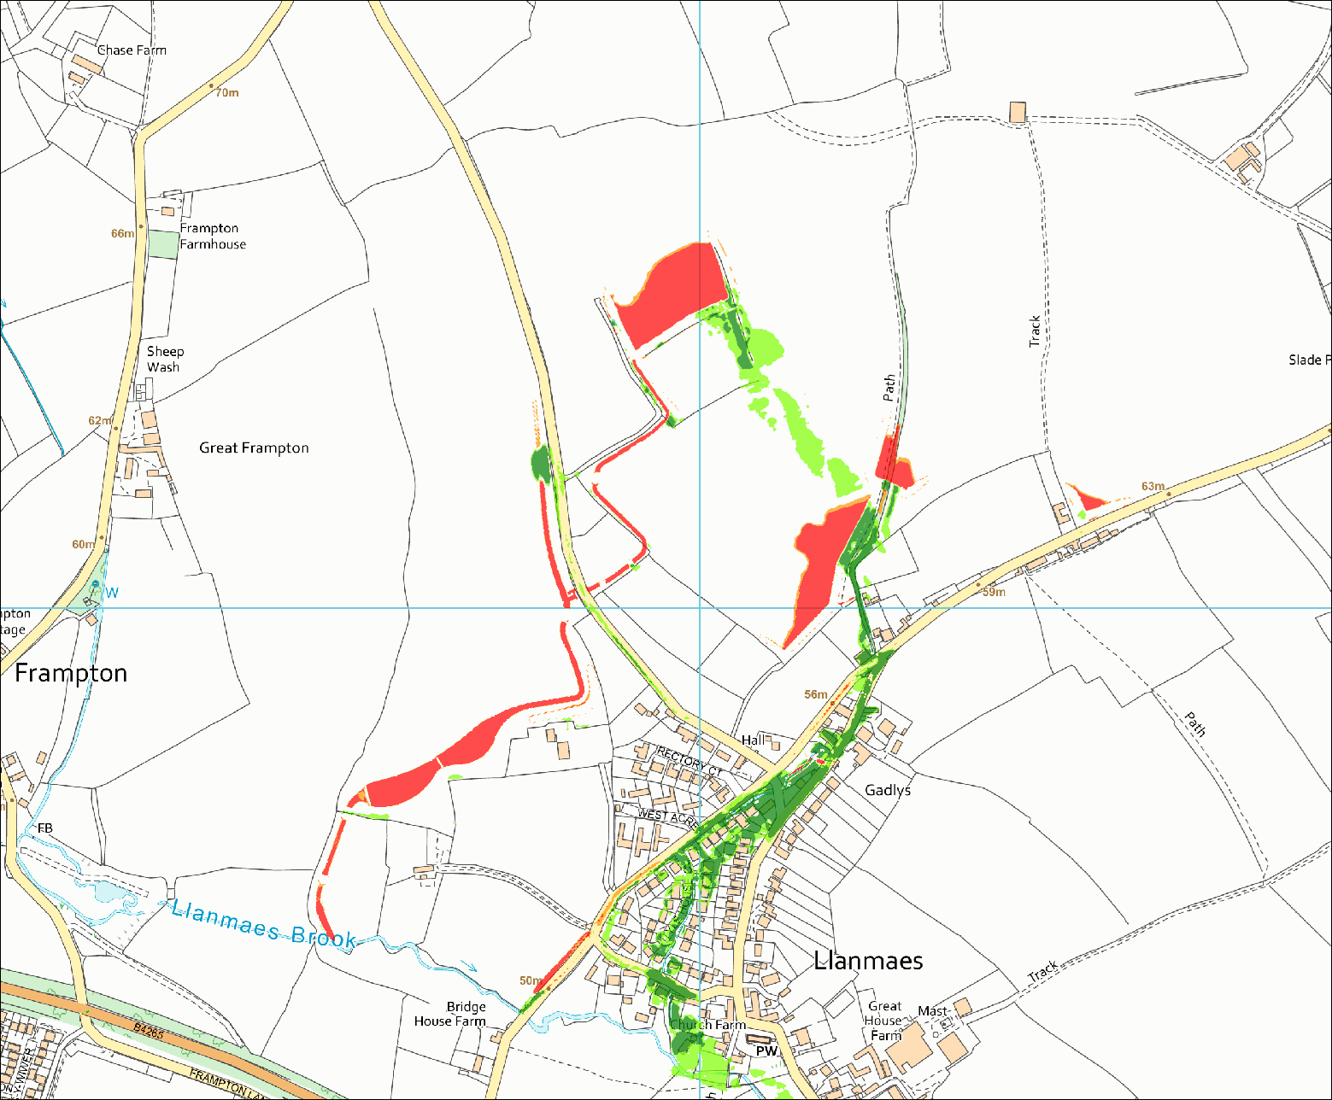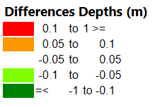
Contains OS data © Crown copyright and database right. All rights reserved. Ordnance Survey Licence number 100019741. Contains Natural Resources Wales data © 2021. All rights reserved.

Figure 9 Depth Differences for 1% AEP + 30%CC

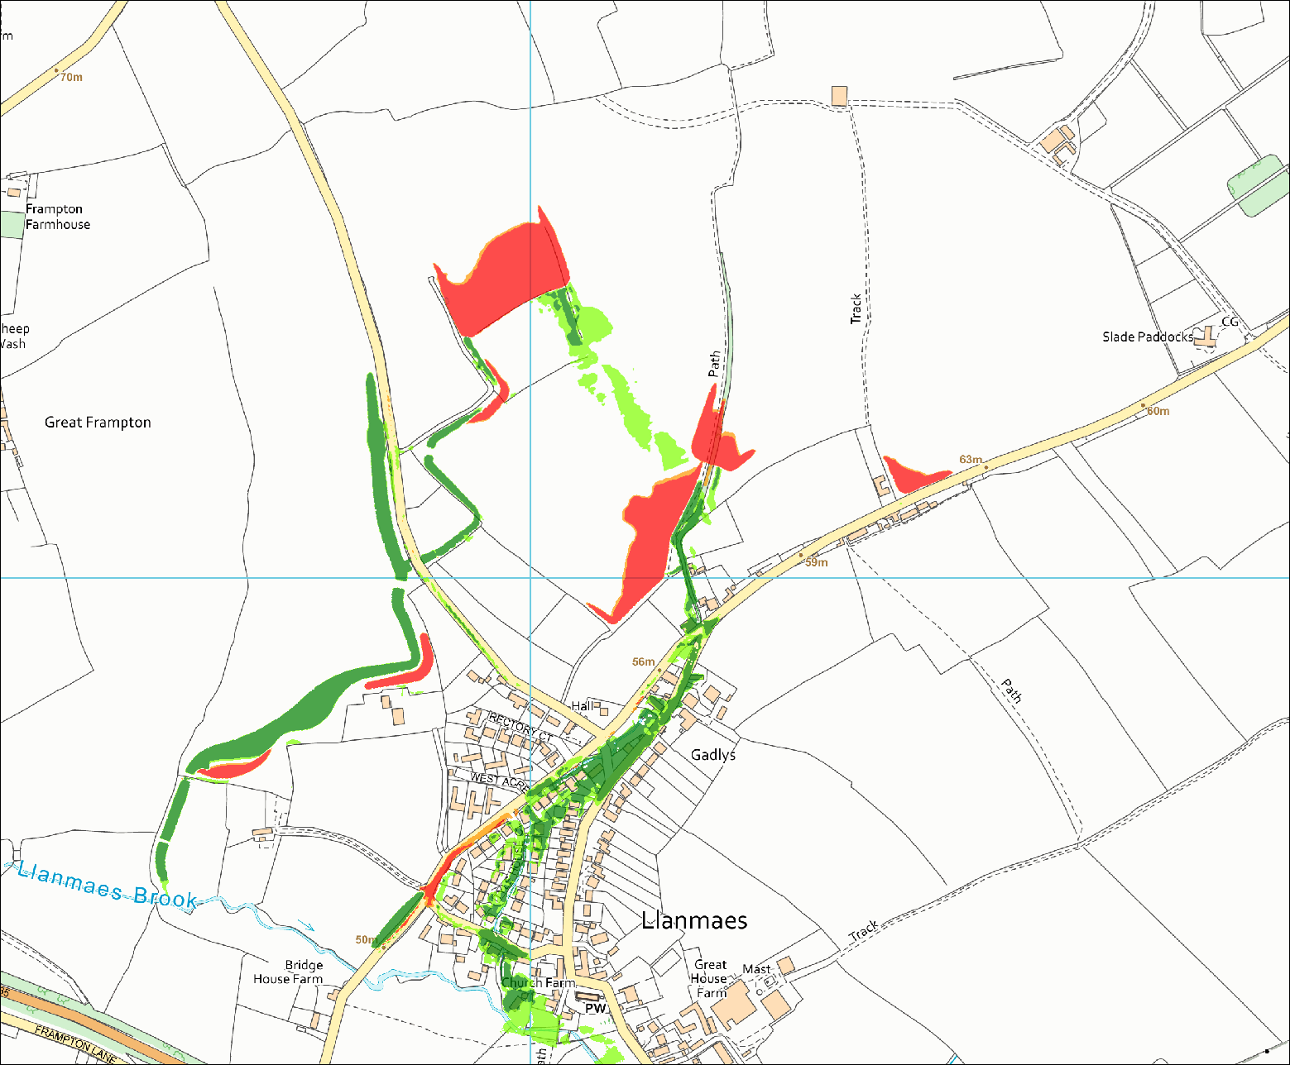
Contains OS data © Crown copyright and database right. All rights reserved. Ordnance Survey Licence number 100019741. Contains Natural Resources Wales data © 2021. All rights reserved.

Figure 10 Elevation Differences for 1% AEP + 30%CC

Conclusions and Recommendations
This is NOT a model Quality Assurance, which will be done by the consultant prior to supplying the model to NRW, and hence this review will not identify all errors within the model. Therefore, these points below should be considered as giving pointers for the modeller to check the model construction/amendments.
It is strongly recommended that the modeller reviews all the comments above. We have the summarised following recommendations.
Recommendations below are colour coded as follows:
Green – No change necessary (suggestion for improvement / good practice but which is unlikely to change the model outcome)
Amber – Changes that are not always compulsory (non-standard method or the method does not follow guidance. May have impacted on model results)
Red – Change needed (omission/error that could make the model findings subject to challenge and which requires correction/further work)

- For future reviews supply only the final model files, removing redundant/superseded files. – number of files provided reduced.
- File naming not consistent, apply consistent file naming convention within the model and follow recommendation within TUFLOW Manual. – Better compliance in file naming.
- Consider reducing the number of control files by the use of “IF…ELSE statement” and fully use of event scenario variables. – *.ecf control file combined with *.tcf, further reduction possible.
- Consider combining similar GIS Layers that have the same function and hence reducing the number of GIS layers e.g. stability layers. – no change on GIS layers, with over 120 GIS layers within the model.
- Consider reducing the model size, to help aid model QA. – Model size reduced.
- Consider providing additional information on the derivation of the storm duration and hyetographs. – Information provided in Llanmaes Flood Alleviation Scheme FCA_Appendix C - Hydraulic Modelling Report.pdf.
- Consider updating attributes within the PO GIS layer to remove “QV” attribute, as this does not appear to be outputting any additional results within the 2d po results file. – completed.
- Consider the use of latest TUFLOW HPC/GPU modelling version to improve run times and reduce the grid resolution to 1 meter. – No change in model methodology.
- When removing bridges ensure that HX lines are also amended e.g. bridge removed at Village Green. – completed.
- Manning’s values have not been altered for the new proposed ditches and storage ponds. The modeller must consider whether these values are still appropriate and document reasoning. – completed.
- Confirm entry and exit losses are as intended for all culverts and are all populated with appropriate values. – only completed in area of interest.
- Ensure GIS building layers are consistent for all scenario runs. – completed.
- Review and update 2d_bc_LlanFAS_040, currently the boundary layer extends inside of the 2d code layer. – completed.
- Review and update 2d_zln_LLANFAS_Banks_042 to remove or connect zpts. – completed.
- Review 2d negative depths and document justification impact these have in the model if any. – covered in the technical report.
- Review 1d negative depths for sensitivity run “S_50pcPRfor”, document justification what impact these have in the model if any. – covered in the technical report.
- Review the topography applied at the Village Green and the proposed cross sections applied at this location as this may impact storage and flood mechanism at this location. – updated to provide better representation.
- Review and update model 1d inflows, Boverton Brook does not have a 1d inflow and therefore is currently running dry, this is incorrect must be amended. – sensitivity runs done for 1.33% AEP as agreed following meeting.
- For the FAS ensure all culverts are applied and operating correctly, especially for Bund1. – covered in the technical report

As with the previous review, this review has focused on the 1% AEP plus 30% climate change baseline and proposed FAS model. The model has had significant changes applied for the proposed model and the mitigation has evolved since the last review.
The model has had updates due to the new proposed mitigation and this appears to have introduced several problems into the model. This review has recommendations from the previous report and additional ones from this review, these are listed above. All these must be considered and addressed.
The current results for the updated FAS reduces flood depths within Llanmaes, without adversely affecting flows at Boverton. The MUR section “7.4 Boverton Brook Inflows” report indicates that the peak flows have been reduced for the 1% AEP + 30% CC. Although the flows for Boverton Brook have not been applied this should not affect the current comparison, however, as it stands the model is incorrect and must be updated to ensure the flows comparisons at Boverton are reliable.
The suggested amendments and points for clarification may only result in minor differences to model output data. However, a robust model able to stand up to close third-party scrutiny is essential when considering that the proposals are to reduce long term flood risk in Llanmaes Village. It is also imperative that the base model and proposed model are as free from error as possible which will in turn produce results that we are confident in supporting a FCA.
AECOM have carried out refinements to the TUFLOW 1D/2D hydraulic and the impact to the results have been small. We note that the flows/stage are lower within Boverton Brook downstream of the B4265 for all the new scenarios supplied.
From the results supplied that Llanmaes village has a reduced flood risk, although parts of the road will have increased depths to the operation/design of the FAS.
Although the model may be refined further it would appear that this would only lead to small changes in the modelled results. Therefore, based on the refined model, NRW suggests that the model results are suitable to support an FCA.

Appendix A

Baseline
 | NRW Reviewed Model (Dec 2021) | Baseline AECOM February 2022 Updates | Comment
TCF | LlanFAS_BL_~s1~_~e1~_070.tcf | LlanFAS_BL_~s1~_~e1~_074.tcf | Combined ECF into TCF + updated control files + 1D domain
 | LlanFAS_BL_~s1~_~e1~_070.ecf
 | LlanFAS_BL_2m_070.tgc | LlanFAS_BL_2m_074.tgc | Updated GIS files (see below)
 | LlanFAS_070.tbc | LlanFAS_BL_072.tbc | Added BL suffix for clarity + updated GIS files
 | bc_dbase_LlanFAS_001 | bc_dbase_LlanFAS_074 | Updated the rainfall profiles (LlanFAS_60min_074_0,3RC.csv) to include the 75yr event
 | StA_Com_60min_002_0,3RC.csv | LlanFAS_60min_074_0,3RC.csv | Added the 1.33% AEP rainfall event
 | 2d_po_LlanFAS_070 | 2d_po_LlanFAS_BL_072 | Added BL suffix for clarity and removed erroneous parameters
 | 1D Domain
 | 1d_nwke_BOV_EXT_FLOOD_RELIEF_033 | 1d_nwke_BOV_EXT_FLOOD_RELIEF_072 | Updated losses for culvert FRC_EAST_01
 | 1d_nwke_LLANFAS_042 | 1d_nwke_LLANFAS_072 | Removed reach L_FAS_009 to homogenise channel
 | 1d_xs_LLANFAS_Drainage_Ditches_040 | 1d_xs_LLANFAS_Drainage_Ditches_072 | Removed cross section A6 from near Frogland's Farm
 | 1d_xs_LLANFAS_042 | 1d_xs_LLANFAS_072 | Updated representation at the Village Green. Removed Cross Section L_FAS_009.csv as cross section US and DS are essentially the same so not required and avoids unnecessary HX connection issues
 | 1d_WLL_LLANFAS_035 | 1d_WLL_LLANFAS_072 | Extended WLL lines at the Village Green where channel updates have been made
 | 2D Domain
TGC | Grid Size = 5800,4700 | Grid Size = 5800,4500 | Reduced domain size to improve simulation time
 | 2d_code_LlanFAS_039 | 2d_code_LlanFAS_072 | Adjusted code boundary in SW corner of Llanmaes Brook catchment to follow railway line
 | 2d_code_LlanFAS_Channel_035 | 2d_code_LlanFAS_Channel_072 | Adjusted code layer to match new HX connection
 | 2d_zln_LLANFAS_Banks_042 | 2d_zln_LLANFAS_Banks_072 | Removed disconnected zpts. Removed Village Green Bridge and connected 2d_zln along Village Green
 | 2d_zsh_LlanFAS_Ditch_Bank_040 | 2d_zsh_LlanFAS_BL_Ditch_Bank_074 | Removed dangling zpts
 | 2d_zsh_StA_Com_Frog_Flowpath_022 | 2d_zsh_LlanFAS_BL_Frog_Flowpath_074 | Removes dangling zpt maintains same elevation
TBC | 2d_bc_LlanFAS_039 | 2d_bc_LlanFAS_072 | Truncated sw boundary to match to code layer
 | 2d_rf_LlanFAS_039 | 2d_rf_LlanFAS_072 | Moved RF boundary in line with the Code change at SW corner of Llanmaes catchment
 | 2d_hxi_LlanFAS_035 | 2d_hxi_LlanFAS_072 | Extend HX connection to remove bridge at Village Green (near XS L_FAS_010)

Proposed
 | NRW Reviewed Model (Dec 2021) | Proposed AECOM February 2022 Updates | Comment
TCF | LlanFAS_DD_~s1~_~e1~_071.tcf | LlanFAS_DD_~s1~_~e1~_075.tcf | Combined ECF into TCF + updated control files + 1D domain
 | LlanFAS_DD_~s1~_~e1~_071.ecf
 | LlanFAS_DD_2m_071.tgc | LlanFAS_DD_2m_075.tgc | Updated GIS files (see below)
 | LlanFAS_DD_071.tbc | LlanFAS_DD_073.tbc | Updated GIS files (see below)
 | bc_dbase_LlanFAS_001 | bc_dbase_LlanFAS_074 | Same as Baseline Model Update
 | StA_Com_60min_002_0,3RC.csv | LlanFAS_60min_074_0,3RC.csv | Same as Baseline Model Update
 | 2d_po_LlanFAS_070 | 2d_po_LlanFAS_BL_072 | Same as Baseline Model Update
 | 2d_po_LlanFAS_065 | 2d_po_LlanFAS_DD_073 | Added DD suffix for clarity no change to the GIS layer parameters
 | BOV_020.tmf | LlanFAS_DD_073.tmf | Added material ID 1 with Manning’s Roughness of 0.033 for representation of the design ditches
 | 1D Domain
 | 1d_nwke_BOV_EXT_FLOOD_RELIEF_033 | 1d_nwke_BOV_EXT_FLOOD_RELIEF_072 | Same as Baseline Model Update
 | 1d_nwke_LLANFAS_DD_057 | No changes made to 1d_nwke_DD from previous submission | N/A
 | 1d_nwke_LLANFAS_DD_USStorage_Drainage_068 | 1d_nwke_LLANFAS_DD_USStorage_Drainage_073 | Updated losses for culvert Di1_Agr_04
 | 1d_xs_LLANFAS_Drainage_Ditches_040 | 1d_xs_LLANFAS_Drainage_Ditches_072 | Same as Baseline Model Update
 | 1d_xs_LLANFAS_DD_057 | 1d_xs_LLANFAS_DD_073 | Updated Bed Elevations of L_FAS_DD_10a, 10b, 10c and 10d to ensure constant gradient
 | 1d_WLL_LLANFAS_DD_058 | No changes made to WLL layer from previous submission | N/A
TGC | 2D Domain
 | Grid Size = 5800,4700 | Grid Size = 5800,4500 | Same as Baseline Model Update
 | 2d_code_LlanFAS_039 | 2d_code_LlanFAS_072 | Same as Baseline Model Update
 | 2d_code_LlanFAS_Channel_035 | 2d_code_LlanFAS_Channel_072 | Same as Baseline Model Update
 | 2d_zln_LLANFAS_DD_Banks_048 | 2d_zln_LLANFAS_DD_Banks_073 | Removed disconnected zpts
 | 2d_zsh_LlanFAS_Ditch_Bank_040 | 2d_zsh_LlanFAS_BL_Ditch_Bank_074 | Same as Baseline Model Update
 | 2d_zsh_StA_Com_Frog_Flowpath_022 | 2d_zsh_LlanFAS_BL_Frog_Flowpath_074 | Same as Baseline Model Update
 | 2d_zsh_LLANFAS_DD_Kerb_063 | 2d_zsh_LLANFAS_DD_Kerb_075 | Removed dangling zpt
 | None present | 2d_mat_LLANFAS_DD_Ditches_073 | Material layer for design ditches to set Manning's value to 0.033
TBC | 2d_bc_LlanFAS_039 | 2d_bc_LlanFAS_072 | Same as Baseline Model Update
 | 2d_rf_LlanFAS_039 | 2d_rf_LlanFAS_072 | Same as Baseline Model Update
 | 2d_hxi_LlanFAS_DD_057 | No changes made to 2d_hxi layer from previous submission | N/A

Baseline Sensitive run with flow in Boverton Brook.
 | NRW Reviewed Model (December 2021) | AECOM February 2022 Updates | Comment
TCF | LlanFAS_BL_~s1~_~e1~_060_S_Bov.tcf | LlanFAS_BL_~s1~_~e1~_074_S_Bov | Combined ECF into TCF + updated control files
 | LlanFAS_BL_~s1~_~e1~_060_S_Bov.ecf
 | LlanFAS_BL_2m_060_S_Bov.tgc | LlanFAS_BL_2m_074_S_Bov.tgc | Updated code layers (see below)
 | LlanFAS_042_S_Bov.tbc | LlanFAS_BL_072_S_Bov.tbc | Updated 2d_bc layer (see below)
TGC | 2d_code_LlanFAS_Bov_001 | 2d_code_LlanFAS_072_S_Bov | Match changes to Baseline at SW corner of Llanmaes catchment.
 | 2d_mat_LLANFAS_building_035 | 2d_mat_LLANFAS_building_070 | Building layer consistent with Baseline simulation
TBC | 2d_bc_LlanFAS_Bov_041 | 2d_bc_LlanFAS_072_S_Bov | Match changes to Baseline at SW corner of Llanmaes catchment

Proposed Sensitive run with flow in Boverton Brook.
 | NRW Reviewed Model (December 2021) | AECOM February 2022 Updates | Comment
TCF | LlanFAS_DD_~s1~_~e1~_068_S_Bov.tcf | LlanFAS_DD_~s1~_~e1~_075_S_Bov.tcf | Combined ECF into TCF + updated control files
 | LlanFAS_DD_~s1~_~e1~_068_S_Bov.ecf
 | LlanFAS_DD_2m_067_S_Bov.tgc | LlanFAS_DD_2m_075_S_Bov.tgc | Updated code layers
 | LlanFAS_DD_066_S_Bov.tbc | LlanFAS_DD_073_S_Bov.tbc | Updated 2d_bc layer
TGC | 2d_code_LlanFAS_Bov_001 | 2d_code_LlanFAS_072_S_Bov | Same as Baseline Model Update
 | 2d_mat_LLANFAS_building_035 | 2d_mat_LLANFAS_building_070 | Same as Baseline Model Update
TBC | 2d_bc_LlanFAS_Bov_041 | 2d_bc_LlanFAS_072_S_Bov | Same as Baseline Model Update

