MEMORANDUM / COFNOD  The Vale of Glamorgan Council Regeneration & Planning  Dock Office, Barry Docks, Barry, CF63 4RT | 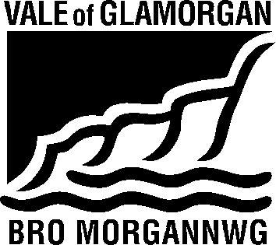

To / I: | Regeneration and Planning |  | From / Oddi Wrth: | Public Rights of Way Officer
Dept / Adran:
 |  |  | My Ref / Fy Cyf: | L12/3
Date / Dyddiad: | 31 August 2021 |  | Tel / Ffôn: | (01446) 704705
Your Ref / Eich Cyf: | P/DC/LC/IR/2021/01082/RG3

Subject / Testyn: Planning Application No. 2021/01082/RG3 (IR) Location : Llanmaes, Llantwit Major
Proposal : This scheme is a Flood Alleviation Scheme for Llanmaes Village.

Public Right of Way No.3 Llanmaes (status – Footpath) will be affected by the scheme and an application to divert the footpath has been received.

The public footpath must be available for safe use by the public at all times. Should the public footpath require temporary closure to assist in facilitating works an order should be sought under the Road Traffic Regulation Act 1984.

No adverse effect should result to the public footpath, the applicant should ensure that materials are not stored on the footpath and no barriers, structures or any other obstructions placed across the legal alignment of the footpath. Any damage to the surface of the footpath as a result of the development is to be made good at the applicants own expense.

Sandra Thomas
On behalf of Gwyn Teague
Public Rights of Way Officer

