MEMORANDUM / COFNOD  The Vale of Glamorgan Council Regeneration & Planning  Dock Office, Barry Docks, Barry, CF63 4RT | 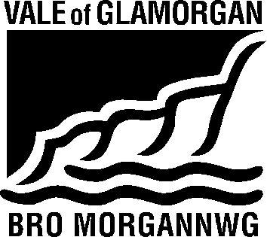

To / I: | Regeneration and Planning |  | From / Oddi Wrth: | Public Rights of Way Officer
Dept / Adran: | Mrs. Sandra Thomas, Dock Office,  Barry.
 |  |  | My Ref / Fy Cyf: | S11/2
Date / Dyddiad: | 14 August 2020 |  | Tel / Ffôn: | (01446) 704705
Your Ref / Eich Cyf: | P/DC/LC/JK/2020/00874/RG3

Subject / Testyn: Planning Application No. 2020/00874/RG3 (JK) Location : St. Nicholas Church In Wales Primary School, St. Nicholas
Proposal : Proposed replacement primary school including additional nursery provision and associated works

As noted on the applicants plans Public Right of Way No.2 St Nicholas (status – Footpath) runs parallel to the eastern boundary of the property crossing the access road.

Public Right of Way No.2 must be kept open and available for safe use by the public at all times., No adverse effect should result to the Public Right of Way, the applicant should ensure that materials are not stored on the Public Right of Way and that any damage to the surface as a result of the development is made good at their own expense.

No barriers, structures or any other obstructions should be placed across the legal alignment of the path. Should the Public Right of Way require temporary closure to assist in facilitating works an order should be sought under the Road Traffic Regulation Act 1984. Temporary closure should not be sought in order to allow construction of permanent obstructions.

A legal diversion or stopping-up order must be obtained, confirmed and implemented prior to any development affecting the Public Rights of Way taking place.

Sandra Thomas
On behalf of Gwyn Teague
Public Rights of Way Officer

