MEMORANDUM / COFNOD  The Vale of Glamorgan Council  Development Services  Dock Office, Barry Docks, Barry, CF63 4RT | 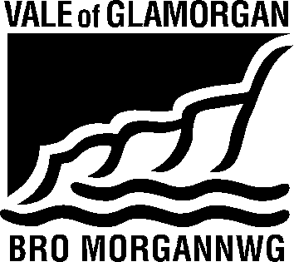

To / I: | Development Services |  | From / Oddi Wrth: | Sandra Thomas  Public Rights of Way Section  Countryside and Economic Projects
 |  |  | My Ref / Fy Cyf: | PROW No.21 and 22 Wenvoe
Date / Dyddiad: | 03 August 2015 |  | Tel / Ffôn: | (01446) 704705
Your Ref / Eich Cyf: | P/DC/LC/SR2/2015/00601/RES |  | Tel / Ffôn: | (01446) 704705

Planning Application No. 2015/00601/RES (SR2)
Location : Land to the West of Port Road, Wenvoe
Proposal : AMENDED DESCRIPTION OF PROPOSAL - Reserved Matters for part of site (relating to outline consent 2013/00884/OUT) for a total of 134 dwellings and associated landscaping and works
Public Rights of Way Nos.21 and 22 Wenvoe cross the development site, and application to divert both paths has been received. The diversion order must be obtained, confirmed and implemented prior to any development affecting the Public Right of Way taking place.

No adverse effect should result to the Public Rights of Way. The applicant should ensure that materials are not stored on the Public Right of Way and that any damage to the surface as a result of the development is made good at their own expense. No barriers, structures or any other obstructions should be placed across the legal alignment of the path.

Should the public right of way require temporary closure to assist in facilitating works an order should be sought under the Road Traffic Regulation Act 1984. Temporary closure should not be sought in order to allow construction of permanent obstructions other than where a public path order has already been confirmed.

Sandra Thomas
On behalf of Gwyn Teague
Public Rights of Way Officer

