MEMORANDUM / COFNOD  The Vale of Glamorgan Council | 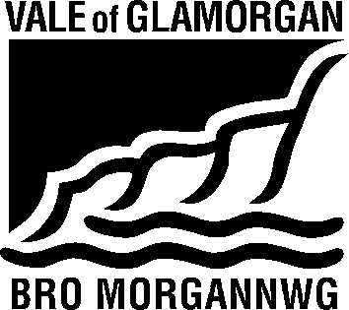

To / I: | Regeneration & Planning |  | From /Oddi Wrth: | Kelly Davies  Rural Housing Enabler
Dept / Adran: | Regeneration & Planning  Vale of Glamorgan Council |  |  | Housing Strategy  Civic Offices  Barry
Date / Dyddiad: | 21 December 2016 |  | Tel / Ffôn: | 01446 709 433
Your Ref / Eich Cyf: | P/DC/LC/SR2/2016/01427/OUT |  | Fax / Ffacs:

Subject: | Planning Consultation Response
Planning Application No. | 2016/01427/OUT (SR2)
Location: | Land Off Cowbridge Road, Eglwys Brewis, St Athan
Proposal: | Residential development of up to 300 units and associated work, including the provision of public open space and strategic access points

Thank you for asking Housing Strategy to consult on this application. We note this proposal is for a residential development of up to 300 units, including the provision of public open space and strategic access points.

There is a demonstrated need for additional affordable housing in the Vale of Glamorgan, as evidenced by the 2015 Local Housing Market Assessment (LHMA) which determined that 559 additional affordable housing units were required each year to meet housing need in the area.

In addition to this research, the Homes4U waiting list, which provides the most accurate and up to date picture of local need, shows there is considerable current need in the St Athan Ward, and the immediate neighbouring ward of Llantwit major with 404 people requiring:

 | St Athan | Llantwit Major
1 Bed Need | 45 | 145
2 Bed Need | 33 | 103
3 Bed Need | 21 | 46
4+ Bed Need | 5 | 6
Total | 104 | 300

It is also worth noting, that in the rural areas of the Vale, housing need is often hidden until a development is proposed, at which time we engage with the local community and community council to encourage households that are in need to make themselves known to us and sign up to the Homes4U and Aspire2Own waiting lists.

Based on the above and in accordance with the draft LDP Supplementary Guidance, we would be seeking 35% affordable housing with a 70/30% tenure mix in favour of social rented units. Based on 300 units total this equates to 105 units of affordable housing. The breakdown should be as follows:

74 Social Rented: 30no one bed flats with own entrances
26no two bed houses
15no 3 bed houses
3no 4 bed houses

- Intermediate: 21 two bed houses
10 three bed houses

The affordable housing units should be pepper potted throughout the site to encourage community cohesion and integration.

Affordable housing units must be DQR compliant.

Kelly Davies

Kelly Davies
Rural Enabling Officer
Visible and Housing Services
Vale of Glamorgan Council / Cyngor Bro Morgannwg
tel / ffôn: 01446 709433
e-mail / e-bost: kdavies@valeofglamorgan.gov.uk

