Objection to wakeboarding at Cosmeston - application number 2016/01441/FUL
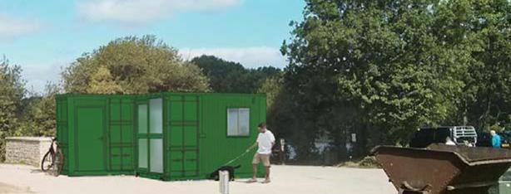
The proposal requires pylon-towers carrying a cable for the towing line, in-water ramps, equipment store, changing facilities + Wake Park office/reception; conversion of visitor-centre store room for a female changing area. It includes a 6 square metre shipping container behind the southern pylon to house the power supply and control equipment for the wakeboarding cable system. Also a pontoon, floating ramps anchored to the lake floor and motorised rescue craft. Trees may need to be felled. Placement of the cable system anchor lines and power supply will account for approximately 15m2
Plaid Cymru (Penarth Branch) reject the proposal for wake-boarding. The tranquil Cosmestson Lakes Country Park opened 1978 and gained Local Nature Reserve status in May 2013 Now it is a haven for wildlife. Part 1 of the Environment Act 2016 sets out Wales' approach to planning and managing natural resources at a national and local level with a general purpose linked to statutory 'principles of sustainable management of natural resources' defined within the Act. We draw attention to Section 6 - Biodiversity and resilience of ecosystems, which places a duty on public authorities to ‘seek to maintain and enhance biodiversity’ so far as it is consistent with the proper exercise of its functions. This replaces the section 40 duty in the Natural Environment and Rural Communities Act 2006, in relation to Wales, and applies to those authorities that fell within the previous duty. https://www.biodiversitywales.org.uk/Environment-Wales-Bill
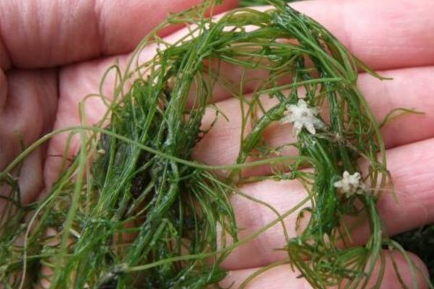
Natural Resources Wales state they have significant concerns about this proposal, pointing out that the scheme lacks the necessary Ecological Construction Method statement and management plan to properly assess the potential impacts of both the scheme and the activities.
It is potentially detrimental to the SSSI. Cosmeston Lakes is a designated SSSI to protect the rare Starry stonewort (Nitellopsis obtuse).
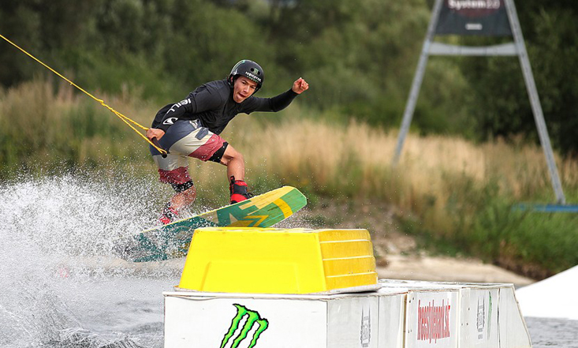
The Wakeboarding sport – riding on a short, wide board resembling a surfboard, steering around obstacles and performing acrobatic manoeuvres while being pulled by a pulley on a raised wire – generates noise, waves and visual impacts that are disturbing to the wildlife inhabiting the nature reserve.
Wakeboarding clearly conflicts with managing Cosmeston to maintain and enhance its nature interest - a requirement for this designated Reserve.
We object to the visual impact of ugly 'tower-supports for the towing wires, also noise from wakeboards hitting the water, shouts from wakeboarders and their supporters. Noise will be worse during the competitions as scheduled, with a PA system. The noise and activity will scare off many if not all the visiting and resident birds. The Council’s claim it to be ‘environment-friendly’ is false. The lake has a resident population of up to 60 Mute Swans. some nesting, and occasionally a similar number of Canada Geese, 100's of Gulls and Coot, other wildfowl from autumn through to spring, birds such as Reed Warbler, Sedge Warbler, Reed Bunting which nest by the lakeside would be disturbed by the wakeboards' wash.
The applicants’ Ecological Baseline report should be rejected
It admits January is suboptimal for undertaking HSI assessment due to a die-back of macrophyte flora. The claim that surveying in winter “is not considered to have affected the outcome of the assessment” is not credible. No mention is made of invertebrates and fauna in hibernation or migration (birds),
They admit (2.22) HSI is an unsuitable assessment tool for these large lakes. A result should therefore be treated with caution.
They dismiss the possibility of otters or water voles by saying ( 3.34) SEWBReC recorded none within 1km of the Country Park and because (3.35) ‘A thorough search of the Application Site and immediate surrounds during the initial site visit recorded no evidence of otter or water vole field signs.’ However on 22 June 2017 about 100 endangered water voles were released in Cosmeston country park in a bid to boost the UK populations, which have reduced by 95% since the 1960s due to a loss of habitat and predation by the American mink. Vale of Glamorgan council and Natural Resources Wales have worked together on a "specially prepared environment" at Cosmeston Country Park in Penarth. http://www.bbc.co.uk/news/uk-wales-south-east-wales-40367392
Cosmeston’s designation as a nature reserve – the 2010 decision.
‘Cosmeston Lakes made an ideal site to be designated as an LNR. The site supports a rich mosaic of habitats including grassland, woodland reed beds and open water. These habitats in turn supported a variety of protected and priority species. The grassland, woodland and hedgerow provided foraging and roosting sites for a number of bat species. The designation of a Local Nature Reserve would reflect the excellent work being done by the Council to manage the areas outstanding natural features. The site provided a valuable resource for the local community. The whole area would be open to the public and there was a good network of paths. An established Educational Programme already served numerous schools. This was a matter for Executive decision.
RESOLVED - (1) T H A T the proposal to designate Cosmeston Lakes Country Park as a Local Nature Reserve be agreed and that consultations to this effect take place.
(2) T H A T if no objections are received, the declaration be progressed.
Reasons for decisions (1&2) To recognise the ecological, educational and recreational importance and tourism potential of the country park.’
Cabinet Minute from 1 Sept 2010
Impact on visitors enjoying the Park
Many people currently enjoy the use of the site for peaceful walking, observing nature, walking. They include active and informed bird watchers. Many elderly visitors and dementia sufferers use the Park and value its tranquillity. The VoG council has to promote well being of all its population - see a ‘Healthier Wales'. It is important that residents of all ages have opportunities to participate in a range of leisure and physical activities. Cosmeston proves an exceptional amenity for older people, helping them to remain independent, healthy and active.
Providing sporting facilities in the Vale
The Council does need to enhance water sports and recreation facilities, but not at the expense of nature and nature-lovers. A recent report in media Wales showed that Council spending on sport and recreation overall has fallen across Wales. Last year, the Vale of Glamorgan spent a net sum of just £5.97 per resident compared to Caerphilly council who spent the most per head, with an average of £40 per resident (£51 in 2014/15). In Cardiff, spending is £4 below the Welsh average of £30 a year per person (£40 in 2012). There are stretches of water available in Barry’s western Dock, with the new water sports centre.
Interference by the Vale’s Regeneration Officers
Their supporting statements show their reasoning is quite contrary to the Nature Reserve. Bob Guy writes that he supports wakeboarding “on balance”, but he is both biased and unqualified to ‘balance’ the harm to nature. He envisages making Cosmeston into a “regional” wakeboarding centre, in order to attract visitors to the area who will spend money here. Yet he fails to comment on the demands this would make on the Park, for refreshment facilities, toilets, parking management, etc. He says the income would amount to half a person-cost. This is unacceptable as a planning reason. He fails to give the cost to the Council of extra staff to manage/oversee the activity and maintain the Park, including litter collection.
Anne Greagsby on behalf of Penarth Plaid Cymru 3 Penarth Head Lane, Penarth CF641BB

