MEMORANDUM / COFNOD  The Vale of Glamorgan Council | 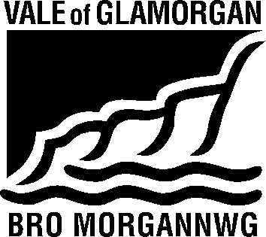

To / I: | Development Services |  | From / Oddi Wrth: | Elisa Faulkner – Affordable Housing Enabler  Housing Strategy
Dept / Adran: | Development Services  Docks Office, |  |  | Civic Offices  Holton Road  Barry  CF5 6AA
 |  |  | My Ref / Fy Cyf:
Date / Dyddiad: | 17 August 2015 |  | Tel / Ffôn: | 01446 709 237
Your Ref / Eich Cyf: |  |  | Fax / Ffacs: | 01446 709 841

Subject: | Planning Consultation Response
Planning Application No. | 2015/00601/RES (SR2)
Location: | Land to the west of Port Road, Wenvoe
Proposal: | AMENDED DESCRIPTION OF PROPOSAL - Reserved Matters for part of site (relating to outline consent 2013/00884/OUT) for a total of 134 dwellings and associated landscaping and works

Thank you for asking Housing Strategy to consult on this application.

We have previously responded to three applications on this site - 2012/00933/OUT, 2013/00884/OUT and 2014/00452/RES.

This proposal allows for 3 extra units, taking the site total from 131 units to 134. In accordance with the S106 (25% onsite affordable housing and 10% offsite contribution) this would trigger 1 extra unit of affordable housing to be delivered onsite.
I understand that the developer has requested this to be accepted as an offsite contribution.

Unfortunately we are unable to accommodate this request and would seek the additional unit to be provided onsite.
We request this to be a 2 bedroom house for social rent and await details of its proposed location on the site.

Elisa Faulkner
Affordable Housing Enabler

