PENARTH – CANOPY COVER 2009
As per LSOAs
Town | LSOAs (Wards) | Total Ward Area (ha) | Town Area in ward (ha) | TCWTC-2009 | Woodland NFI (ha) | Total Cover (ha) | Percentage Total Cover (%) | WIMD 2011
Canopy Cover %
WIMD 2011
Penarth | Cornerswell 1 | 21.98 | 21.98 | 1.96 | 0.12 | 2.08 | 9.5 | 951 - 1896
Penarth | Cornerswell 2 | 30.99 | 30.99 | 3.91 | 1.01 | 4.92 | 15.9 | 571 - 950
Penarth | Cornerswell 3 | 68.90 | 48.89 | 6.55 | 2.15 | 8.7 | 17.8 | 951 - 1896
Penarth | Cornerswell 4 | 20.40 | 20.40 | 1.7 | 0.54 | 2.24 | 11.0 | 951 - 1896
Penarth | Dinas Powys 3 | 76.17 | 2.15 | 0.69 | 0.00 | 0.69 | 32.1 | 951 - 1896
Penarth | Llandough | 161.32 | 110.19 | 0.14 | 14.32 | 14.46 | 13.1 | 951 - 1896
Penarth | Plymouth (The Vale of Glamorgan) 1 | 105.54 | 102.12 | 14.16 | 6.09 | 20.25 | 19.8 | 951 - 1896
Penarth | Plymouth (The Vale of Glamorgan) 2 | 178.38 | 69.18 | 7.49 | 4.19 | 11.68 | 16.9 | 951 - 1896
Penarth | Plymouth (The Vale of Glamorgan) 3 | 52.34 | 52.27 | 7.26 | 0.70 | 7.96 | 15.2 | 951 - 1896
Penarth | St. Augustine's 1 | 38.28 | 35.31 | 6.41 | 2.26 | 8.67 | 24.6 | 951 - 1896
Penarth | St. Augustine's 2 | 18.16 | 18.16 | 0.98 | 0.00 | 0.98 | 5.4 | 951 - 1896
Penarth | St. Augustine's 3 | 29.68 | 29.68 | 2.3 | 2.38 | 4.68 | 15.8 | 951 - 1896
Penarth | St. Augustine's 4 | 54.34 | 60.56 | 3.22 | 8.12 | 11.34 | 18.7 | 951 - 1896
Penarth | Stanwell 1 | 33.97 | 32.22 | 4.83 | 0.05 | 4.88 | 15.1 | 951 - 1896
Penarth | Stanwell 2 | 25.73 | 25.73 | 2.96 | 1.30 | 4.26 | 16.6 | 951 - 1896
Penarth | Stanwell 3 | 36.07 | 30.39 | 3.9 | 0.17 | 4.07 | 13.4 | 571 - 950
Penarth | Sully 3 | 310.11 | 21.86 | 3.77 | 0.00 | 3.77 | 17.2 | 951 - 1896
There will be part-LSOAs of minor hectarage within urban extent that give misleading CC e.g. Dinas Powys 3 in Penarth’s case!
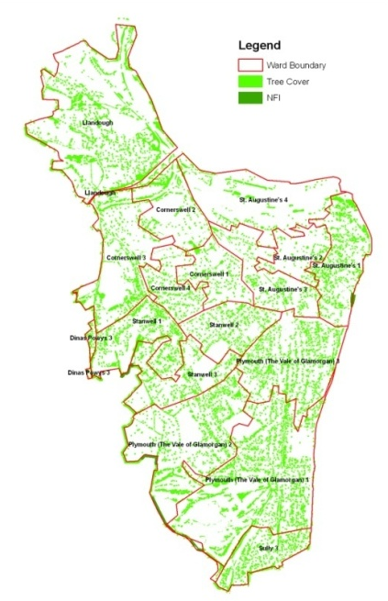

Sorry a rather poor map generated by the previous contractor – tree cover has been depicted ‘cartographically’ rather than real size – so perhaps gives an over generous impression……but at least can see LSOAs spatially depicted. We’ll improve on this for the County Report.

