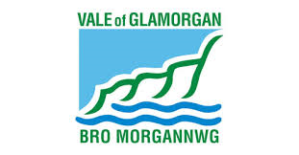
2020
Roberts, Marcus L
Building Services, The Vale of Glamorgan Council
3/31/2020
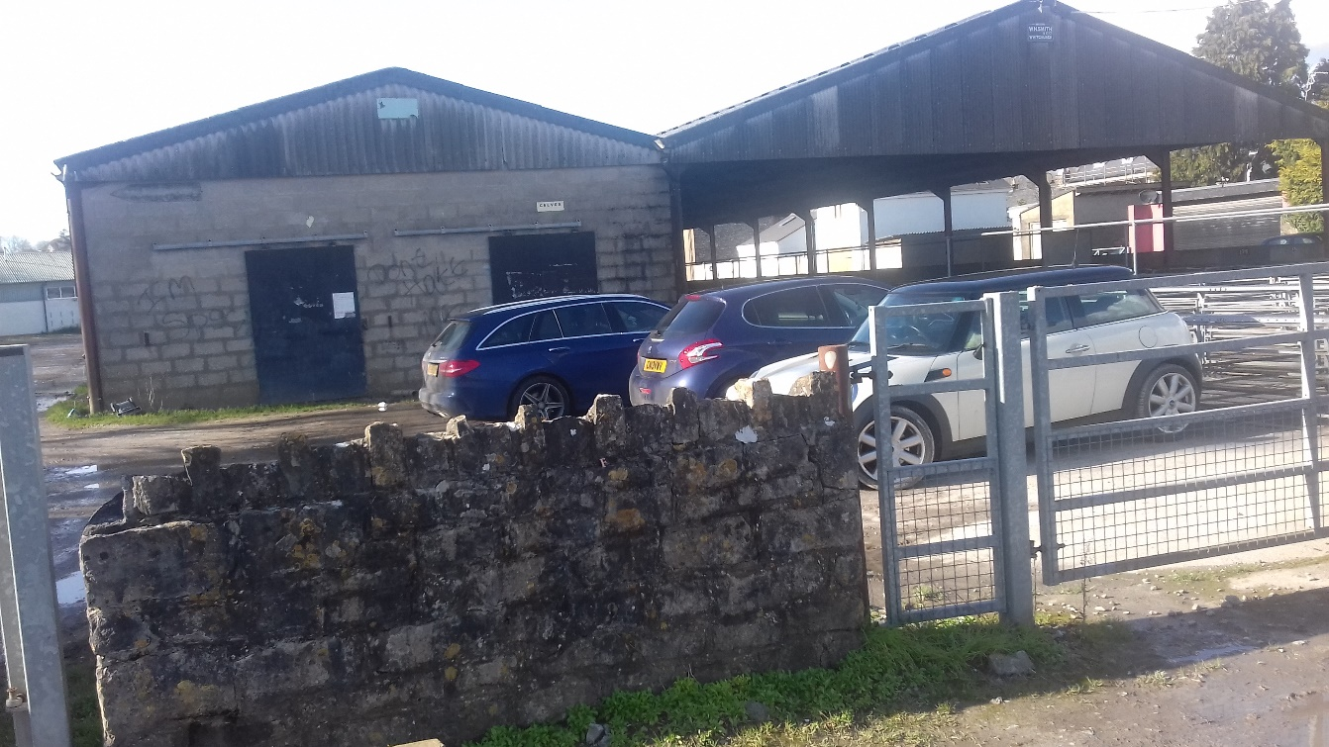
Heritage Impact Statement.

Heritage Impact Statement.
Demolition of Cowbridge Sheep Market, The Butts, Cowbridge, CF71 7AP:
Inclusive of Pens & Auction area, Livestock Sheds, Market Office & Former Café plus redundant Public Conveniences.
Overview.
The Cowbridge livestock market will cease to operate after the 31st March 2020.
The current operators, Glamorgan Marts, will not be extending the licence to operate nor renewing the lease of the site from The Vale of Glamorgan Council.
The existing site buildings are in very poor repair & would require significant investment to bring the site up to modern standards.

Proposed Change.
The Vale of Glamorgan Council proposes to demolish the Livestock Shed & sales pens, the market office & former café, plus the redundant public toilets on The Butts.
The concrete bases to be left in situ and areas graded with clean stone to provide an area for public parking.

Objective of the Proposed Change.
The Livestock Sheds, Pens & Auction area proposed for demolition comprises of 2 steel framed agricultural buildings.
The first bay, the main auction area, is partly open with corrugated Asbestos Cement sheeted roof & timber clad sides, Concrete bay’s laid to falls with run-off channels, steel fenced livestock pens. The cladding & rainwater goods are in poor repair & dangerous in parts.
The second bay, livestock shed, is steel frame in-filled with solid concrete block constructed walls with corrugated asbestos cement clad roof & concrete base. The cladding & rainwater goods are in poor repair & dangerous in parts.
The concrete floors are uneven & are hazardous for persons using the area; the project would allow us to screed over the channels & create a safe level surface.
The Market Office is a traditional build single storey office, store & café. The office remains in use whilst the market operates but the café is no longer functional.
The public conveniences situated on The Butts are of concrete block & brick construction with stone façade & mono pitched roof.
The cessation of market activities at the site renders all existing site buildings surplus to requirements. All these buildings are in poor repair.
The objective of the change is to remove the asbestos materials safely, to demolish each of the buildings in an orderly fashion thereby removing the elements which could be considered dangerous to the public.
The concrete bases would be left in-situ, but any holes or hazards would be filled to create a level surface with fine concrete. The surface areas would be graded with clean stone.
The market site would then be levelled to provide the Town with much needed additional parking.

The Case for Demolition.
The current structures are not considered fit for purpose & are not deemed suitable for cost effective renovation or modernisation.
If left in situ they would deteriorate further & become more of an eyesore in what is a popular Town.
The proposed demolition will ensure that any elements that pose a risk to the public would be removed.
Demolition therefore, offers the best option when considering conservation holistically.

Proposed Schedule of Work.
The Vale of Glamorgan Council would take possession of the site on 1st April 2020.
The site would initially be cordoned off with security fencing to prevent unauthorised access & to provide a secure area for detailed surveys to be undertaken.
The Council, on completion of all surveys & statutory applications, would appoint competent contractors to undertake the demolition in stages;
- Asbestos removal; including all buildings. September/October 2020.
- Demolition of redundant public conveniences. September 2020.
- Remediation of the area where public conveniences have been removed utilising reclaimed stone from demolition. October 2020.
- Demolition of Livestock buildings including sheep pens, auction areas. October/ November 2020.
- Grading & levelling of the main surface areas. November 2020.
- Demolition of the Market Office & levelling of ground. November/December 2020.

Conservation Area Impact – Demolition.

The market buildings & public conveniences are not listed.

The buildings earmarked for demolition have no period features or character inside or out and are of very plain & dilapidated appearance.

Therefore, the Council believe that the proposed demolition will not have any negative impact upon the Conservation Area, both from an architectural heritage or ecological perspective.

The Council is keen to minimise the impact of proposed alterations on the immediate wild/plant life at the site. No Trees or existing grassed areas will be impacted by the proposed changes.

Conservation Area Impact – Addition.

The demolition of the redundant site buildings would enable the Council to provide increased parking spaces to an already heavily congested town centre to encourage further visitors.

The increased capacity in parking & visitor numbers would benefit local businesses.

The remediation of the demolished site would remove derelict & dilapidated buildings bringing the space back into beneficial use so that it is no longer a risk.

Justification for Demolition.

The demolition & reinstatement work is necessary in the long-term interest of the site & it’s value to the town.

The opinion is offered because demolition & the proposed reinstatement means that legacy issues due to the existing structure’s poor condition will be eliminated.

Demolition is deemed necessary both for safety reasons and as the most cost-effective measure to ensure the site is safe, prevents exposing the public to risk & provides for a meaningful & practical use that would be beneficial to the town.

For the above reasons the Council is requesting permission to proceed with the demolition as outlined in this Impact Statement.

