17 March 2015

Mr. M. Goldsworthy

(01446) 704661

P/DC/MG/2013/00334/FUL
Developmentcontrol@valeofglamorgan.gov.uk

The Vale of Glamorgan Council

Dock Office, Barry Docks,Barry CF63 4RT

Tel: (01446) 700111
TCyngor Bro Morgannwg
Swyddfa’r Doc, Dociau’r Barri, Y Barri CF63 4RT
Ffôn: (01446) 700111

www.valeofglamorgan.gov.uk

Date/Dyddiad:

Ask for/Gofynwch am:

Telephone/Rhif ffon:

Your Ref/Eich Cyf:

My Ref/Cyf:

e-mail/e-bost:
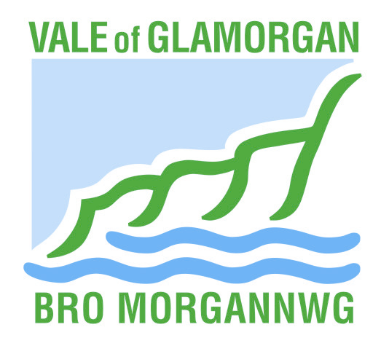

Coastal Oil and Gas Limited,
Unit 9, Bridgend Business Centre,
Bridgend.
CF31 3SH

Dear Sir/Madam,

Town and Country Planning Act, 1990 (as amended)
Application No. 2013/00334/FUL
Location ; Unit 20, Sutton Spring Road, Llandow Trading Estate
Proposal : To drill a single vertical exploration borehole

I refer to the above referenced planning permission approved on 4 October 2013 and the details submitted in respect of conditions attached to that permission.

Having considered the submitted details, I would advise as follows: -

Details Approved

Condition 16.:
Prior to the commencement of development details of measures for wheel washing and dust suppression shall be submitted to and approved in writing by the Local Planning Authority and the approved measures shall be fully implemented on site prior to the commencement of any works and shall thereafter be so retained for the duration of the development unless the Local Planning Authority gives prior written consent to any variation.

Reason:

To ensure highway safety and that the amenities of the area are not adversely affected and in order to ensure compliance with Policy ENV27 of the Unitary Development Plan.
Details received on : 17 December 2014
Status: Details Approved on 17 March 2015

Please note that conditions can only be fully discharged when the development is completed in accordance with the details hereby approved and in conjunction with the approved plans and decision notice. You should therefore ensure that you are aware of the full requirements of each condition identified in your decision notice.

Should you wish to discuss any matter further, please contact the case officer, Mr. M. Goldsworthy on the following contact number 01446 704661.

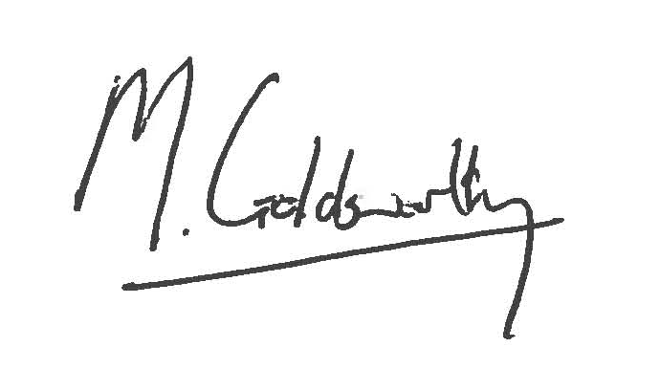Yours faithfully,

M. Goldsworthy
Operational Manager Development & Building Control

