SAVE HEADLANDS TREES with Tree Protection Orders - TPOs
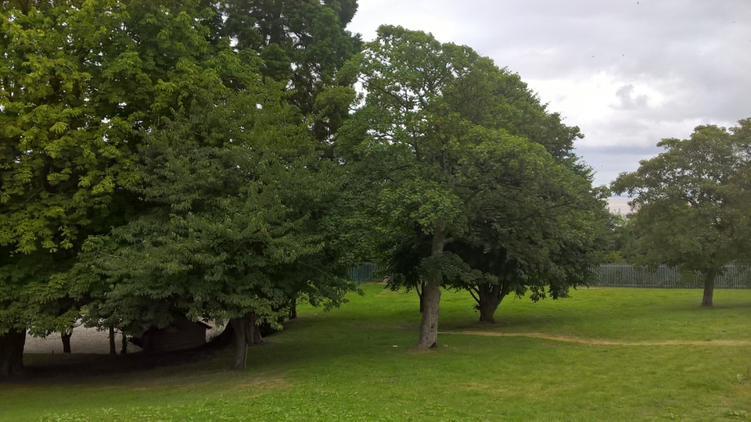
Planning Application 2016/00773/TPO
There is an application to fell nine Penarth Trees with TPOs. This is part of a scheme to fell 19 trees and reduce the crowns on many others which will radically change this historic parkland landscape up to the cliff-edge of Penarth Headland although it’s a habitat for owls and perhaps other protected species, the relevant species assessment has not been done.
Seven Reasons why you should refuse this application
1. Require the applicants to supply proper information, sufficient to identify the individual trees, and allow independent persons to inspect the TPO trees and enable judgement in context of their amenity value and listing critieria. The original TPO documents should be provided.
2. Consider making TPOs to cover all or most of the 40 trees that are intended for felling and lack protection at present. The scale of the felling of mature trees means probably significant impacts on both landscape and biodiversity. Both should be assessed.
3. Habitats Regs assessment is also needed for protected species, given that owls are known to forage and inhabit this area. These would inform and support the decision on further TPOs.
4. The Council's biodiversity officer should be consulted, specifically over protecting the area under ancient and semi-mature woodland/parkland of Welsh government policy, in consultation with NRW specialists.
5. If any TPO trees are in the end to be felled, the Council must consider issuing tree replacement notices for each tree lost. http://gov.wales/docs/desh/policy/971001tan10en.pdf.
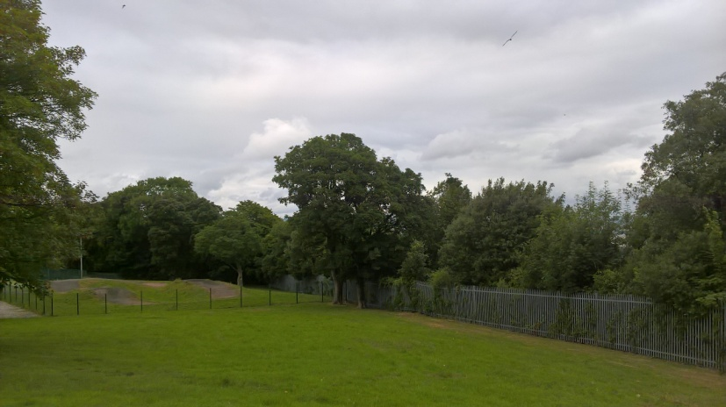
6. Given that more time is needed for these assessments and decision, the Council should re-start the 6-week period once the proper required information is received for identifying the TPO trees. That information should include the reasons given in each TPO notice.
7. One could suspect that this tree clearance is in advance of any planning application for building on MG 2(25) Headlands School, St. Augustine’s Road to avoid the more difficult checks and balances as in POLICY MD 3 - DESIGN OF NEW DEVELOPMENT like environmental impact assessments etc http://www.valeofglamorgan.gov.uk/Documents/Living/Planning/Policy/LDP-2013/01-LDP-Deposit-Plan-Written-Statement-2013.pdf

