Date/Dyddiad | 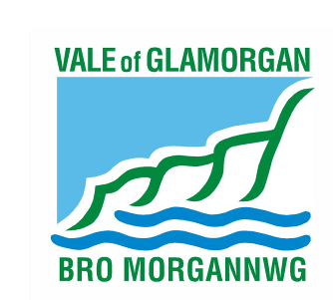  16 November 2016
Ask for/Gofynwch am | Mr. Ian Robinson
Telephone/Rhif ffôn | 01446 704777
Fax/Ffacs
e-mail/e-bost | IRibinson@valeofglamorgan.gov.uk
Your Ref/Eich Cyf
My Ref/Cyf | P/DC/IR/2016/00305/RG3

The First Minister,
Welsh Assembly Government,
Crown Buildings,
Cathays Park,
Cardiff.
CF10 3NQ

Dear Sir/Madam,

Town and Country Planning Act, 1990 (as amended)
Planning Application No. 2016/00305/RG3 (IR)
Location : Land adjacent A4226, Five Mile Lane, Barry
Proposal : Proposal is for on line improvements to the existing A4226 between Waycock Cross Roundabout in Barry and the lay-by to the north of the Welsh Hawking Centre and an off line new road provision to the east of the existing A4226 which will reconnect with the existing A4226 just to the south of Blackland Farm

In accordance with Section 22(5) of The Town and Country Planning (Environmental Impact Assessment) (Wales) Regulations 2016 I enclose a disk containing additional information that has been received in respect of planning application 2016/00305/RG3.

If you require additional information or clarification on this, please do not hesitate to contact Mr. I. Robinson on 01446 704777.

Yours faithfully,

Operational Manager Development Management

