MEMORANDUM / COFNOD  The Vale of Glamorgan Council | 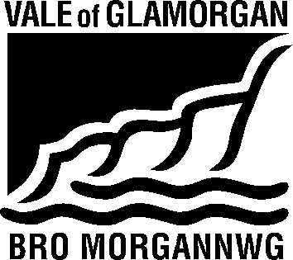

To / I: | Development Services |  | From / Oddi Wrth: | Elisa Faulkner – Affordable Housing Enabler
Dept / Adran: | Development Services  Docks Office, |  |  | Public Sector Housing,The Alps Depot,  Wenvoe.
 |  |  | My Ref / Fy Cyf:
Date / Dyddiad: | 02/09/14 |  | Tel / Ffôn: | 01446 709 237
Your Ref / Eich Cyf: |  |  | Fax / Ffacs: | 01446 709 841

Subject: | Planning Consultation Response
Planning Application No. | 2014/00933/FUL (YP)
Location: | Land at Pentre Meyrick, Pentre Meyrick
Proposal: | Development of 13 affordable homes, access arrangements and associated works

Thank you for asking Housing Strategy to consult on this application.

There is a demonstrated need for additional affordable housing in the Vale of Glamorgan, as evidenced by the 2010 Local Housing Market Assessment (LHMA) which determined that 915 additional affordable housing units were required each year to meet housing need in the area.

In addition to this research, the Homes4U waiting list, which provides the most accurate and up to date picture of local need, shows there is considerable current need in the Cowbridge ward, with 160 people requiring:

1 Bed Need | 100
2 Bed Need | 45
3 Bed Need | 7
4 Bed Need | 6
5 Bed Need | 2
Total | 160

There are a futher 59 households who have stated they require housing “Anywhere in the Rural Vale”.

The Housing Strategy department is supportive of this proposal and have worked closely with the landowner and Housing Association in bringing this site forward. It represents an innovative opportunity to develop much needed rural affordable housing in an appropriate location.

The landowner, who runs a large farm estate in the Vale, will be gifting the land to the Housing Association, in return for nomination rights on two of the thirteen properties, which they will use for retiring staff leaving tied accommodation on the estate. These two properties will remain in ownership of the Housing Association and if the landowner does not have a suitable nomination at any time, they will be allocated via the Homes4U waiting list.
Land availability for affordable housing is a particular problem in the Vale and we support this innovative solution.

In partnership with the Housing Association, we met with the Penllyn Community Council in March 2014 to discuss the proposal and the principle of a Local Lettings Policy which could be applied to the site. This was then followed up with a public consultation event in Penllyn, which was very well attended by the local community. Since then, we have received numerous enquiries from local residents who would be eligible under the terms of a Local Lettings Policy.

Many of these are currently living in Pentre Meyrick itself and include young people working locally in farming, education and a local small business owner. We have also had enquiries from people with caring responsibilities for elderly parents in the village who cannot afford to move to the area.

They have all been encouraged to join the Homes4U waiting list and we will continue to work closely with the community, if planning permission is granted, to ensure the homes are allocated to local people, satisfying the terms of the Local Lettings Policy which will be formulated by the Community Council and the Affordable Housing Enabler.

We hope that the Planning Committee will find in favour of this innovative and much needed development.

Elisa Faulkner

Affordable Housing Enabler

