MEMORANDUM / COFNOD  The Vale of Glamorgan Council | 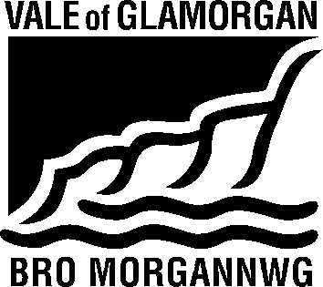

To / I: | Regeneration & Planning |  | From / Oddi Wrth: | Kelly Davies
Dept / Adran: | Regeneration & Planning  Vale of Glamorgan Council |  |  | Visible & Housing Services  Civic Offices, Barry
 |  |  | My Ref / Fy Cyf:
Date / Dyddiad: | 19/09/2016 |  | Tel / Ffôn: | 01446 709 433
Your Ref / Eich Cyf: |  |  | Fax / Ffacs:

Subject: | Planning Consultation Response
Planning Application No. | 2015/00249/FUL (SR2)
Location: | Land to East of St Nicholas
Proposal: | Development of 100 houses and associated open space vehicular and pedestrian access, landscaping and infrastructure, including the demolition of Emmaville

Thank you for asking Housing Strategy to consult on this application. We note that the proposal is for the construction of 100 dwellings, to include 35 affordable housing units located in St Nicholas, which falls within the Wenvoe Ward.

There is a demonstrated need for additional affordable housing in the Vale of Glamorgan, as evidenced by the 2015 Local Housing Market Assessment (LHMA) which determined that 559 additional affordable housing units were required each year to meet housing need in the area.

In addition to this research, the Homes4U waiting list, which provides the most accurate and up to date picture of local need, shows there is considerable current need in the Wenvoe Ward, and the immediate neighbouring ward of Peterston-Super-Ely, with a total of 85 people requiring:

 | Wenvoe | Peterston-Super-Ely
1 Bed Need | 23 | 9
2 Bed Need | 31 | 2
3 Bed Need | 13 | 4
4 Bed + Need | 2 | 1
Total | 69 | 16

It is also worth noting, that in the rural areas of the Vale, housing need is often hidden until a development is proposed, at which time we engage with the local community and community council to encourage households that are in need to make themselves known to us and sign up to the Homes4U and Aspire2Own waiting lists.

We understand and accept that there is provision for thirty-five affordable housing units, supplemented with a 5% off site contribution, to meet the requirements of the draft LDP (2011- 2016) and associated SPG for 40% affordable housing contribution. In addition, we confirm that we are happy with the location and mix of the affordable housing units.

Based on a total of 35 units the breakdown is as follows:
Social Rented:
10 x 1bed flat with own entrances
12 x 2bed house
3 x 3 bed house

Intermediate:
10 x 2 bed houses

All affordable housing units must be DQR compliant.

Kelly Davies

Kelly Davies
Rural Enabling Officer
Visible and Housing Services
Vale of Glamorgan Council / Cyngor Bro Morgannwg
tel / ffôn: 01446 709433
e-mail / e-bost: kdavies@valeofglamorgan.gov.uk

