MEMORANDUM / COFNOD  The Vale of Glamorgan Council  Regeneration & Planning  Dock Office, Barry Docks, Barry, CF63 4RT | 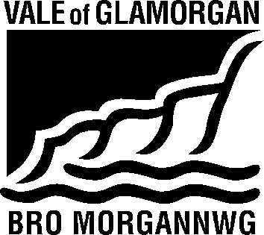

To / I: | Steve Butler |  | From / Oddi Wrth: | Housing Strategy,  Civic Offices,  Holton Road,  Barry
Dept / Adran: | Regeneration and Planning
 |  |  | My Ref / Fy Cyf: | P/DC/LC/SDB/2017/00746/RES
Date / Dyddiad: | 5 September 2017 |  | Tel / Ffôn: | (01446) 709433

Subject / Testyn: Planning Application No. 2017/00746/RES (SDB)
Location : Land off Cardiff Road/Cross Common Road, Dinas Powys
Proposal : Approval of all matters reserved.

Thank you for the opportunity to comment on these proposals.

We have examined the revised plans and are satisfied that they now meet the Council’s affordable housing requirements.

Regards,

P. Toms

Housing Solutions and Supporting People Team Leader

