SULLY AND LAVERNOCK COMMUNITY COUNCIL
CYNGOR CYMUNED ABERSILI A LARNOG
Council Office  Jubilee Hall  Smithies Avenue  Sully  Penarth  CF64 5SS | 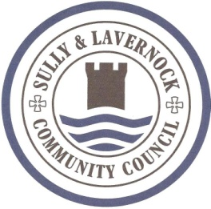 |  |  |  |  | Swyddfa’r Cyngor  Neuadd Jiwbili  Smithies Avenue  Abersili  Penarth  CF64 5SS
Tel: 029 2053 0006  Email: sullycouncil@btconnect.com  Clerk to the Council: |  |  |  | Ffôn: 029 2053 0006  Ebost: sullycouncil@btconnect.com  Clerc i’r Cyngor:
 |  |  |  |  | Date: 6th April 2018

Dear Miss Angharad Hobbs,
2018/00290/FUL – 5, Meadow View Court, Sully.
Change roofing finish and extend rear conservatory. Build new rear conservatory. Extend front porch and form new balcony to side elevation and new boundary wall.

Sully and Lavernock Community Council have no objection to the application.

Regards,
Councillor Michael Garland (Sully and Lavernock Community Council)
3 Plover Way, Lavernock Park, Lavernock, Penarth. CF64 5FU

