MEMORANDUM / COFNOD  The Vale of Glamorgan Council | 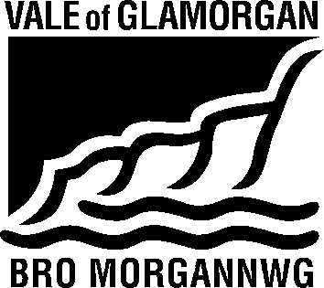

To / I: | Regeneration & Planning |  | From / Oddi Wrth: | Kelly Davies  Rural Housing Enabler
Dept / Adran: | Regeneration & Planning  Vale of Glamorgan Council |  |  | Housing Strategy  Civic Offices  Barry
 |  |  | My Ref / Fy Cyf:
Date / Dyddiad: | 27/01/17 |  | Tel / Ffôn: | 01446 709433
Your Ref / Eich Cyf: |  |  | Fax / Ffacs:

Subject: | Planning Consultation Response
Planning Application No. | 2016/01520/OUT
Location: | Land West of Swanbridge Road, Sully
Proposal: | Residential Development of up to 190 units with associated access and associated works

Thank you for asking Housing Strategy to consult on this application. We note that the proposal is for up to 190 units and associated works.

There is a demonstrated need for additional affordable housing in the Vale of Glamorgan, as evidenced by the 2015 Local Housing Market Assessment (LHMA) which determined that 559 additional affordable housing units were required each year to meet housing need in the area.

In addition to this research, the Homes4U waiting list, which provides the most accurate and up to date picture of local need, shows there is considerable current need in Sully Ward, and the immediately adjacent Wards, with a total of 938 people requiring:

 | Sully | Dinas Powys | Castleland | Cadoc | Plymouth
1 Bed | 10 | 88 | 228 | 130 | 42
2 Bed | 17 | 50 | 131 | 88 | 27
3 Bed | 5 | 19 | 43 | 22 | 5
4+ Bed | 1 | 7 | 17 | 7 | 1
 | 33 | 164 | 419 | 247 | 75

It is also worth noting, that in the rural areas of the Vale, housing need is often hidden until a development is proposed, at which time we engage with the local community and community council to encourage households that are in need to make themselves known to us and sign up to the Homes4U and Aspire2Own waiting lists.

Based on the above, and in accordance with the draft LDP Supplementary Guidance, we would be seeking 40% affordable housing with a 70/30% tenure mix in favour of social rented units.

All affordable housing units must be DQR compliant.

Kelly Davies

Kelly Davies
Rural Enabling Officer
Visible and Housing Services
Vale of Glamorgan Council / Cyngor Bro Morgannwg
tel / ffôn: 01446 709433
e-mail / e-bost: kdavies@valeofglamorgan.gov.uk

