MEMORANDUM / COFNOD

The Vale of Glamorgan Council
Regeneration and Planning
Dock Office, Barry Docks, Barry, CF63 4RT

To / I: | Regeneration and Planning |  | From / Oddi Wrth: | Housing Strategy
Dept / Adran: |  |  |  | Affordable Housing Enabler,  Civic Offices,  Holton Road,  Barry
 |  |  | My Ref / Fy Cyf: | P/DC/LC/SR2/2016/01427/OUT
Date / Dyddiad: | 14 June 2017 |  | Tel / Ffôn: | (01446) 709433
Your Ref / Eich Cyf:

Subject / Testyn: Planning Application No. 2016/01427/OUT (SR2)
Location : Land off Cowbridge Road, St Athan
Proposal : Residential development of up to 300 units and associated work, including the provision of public open space and strategic access points

With reference to the additional documents received we have no further comments to make.

We support the application in principle as per previous memo.

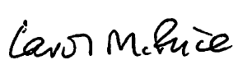

Carol Price
Rural Housing Enabler

