Dear Sir,
I would like to register my opposition to the development of this Greenfield site along Cowbridge road.
The area chosen is directly alongside a small brook, which during winter will often flood the highway both on Cowbridge road and on the opposite side towards the village of flemingston. With the development of the land for these 300 houses all of that rain water that would typically be soaked up by the field would be diverted directly into this stream, greatly increasing the risk of flooding in an area already prone to flooding.
Please see below for pictures taken this year after some fairly routine rainfall.
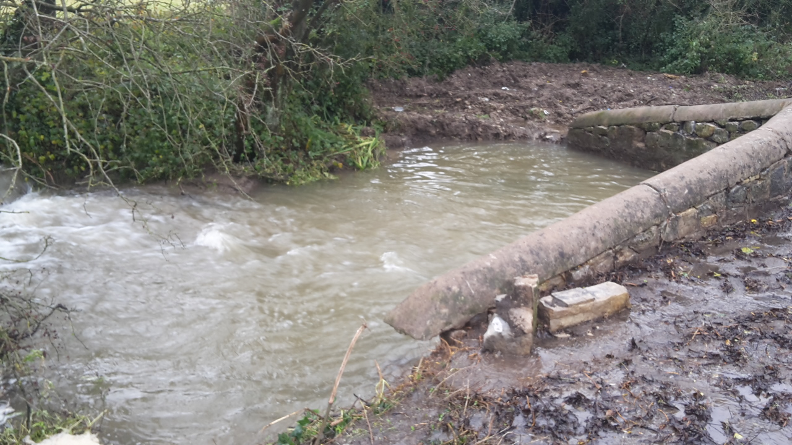
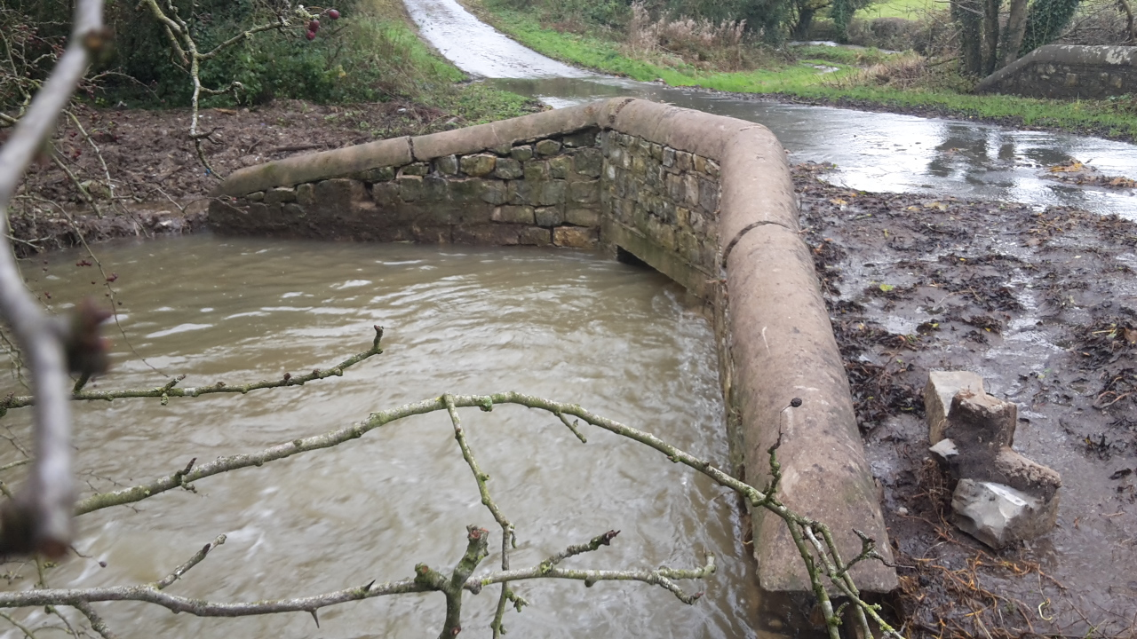

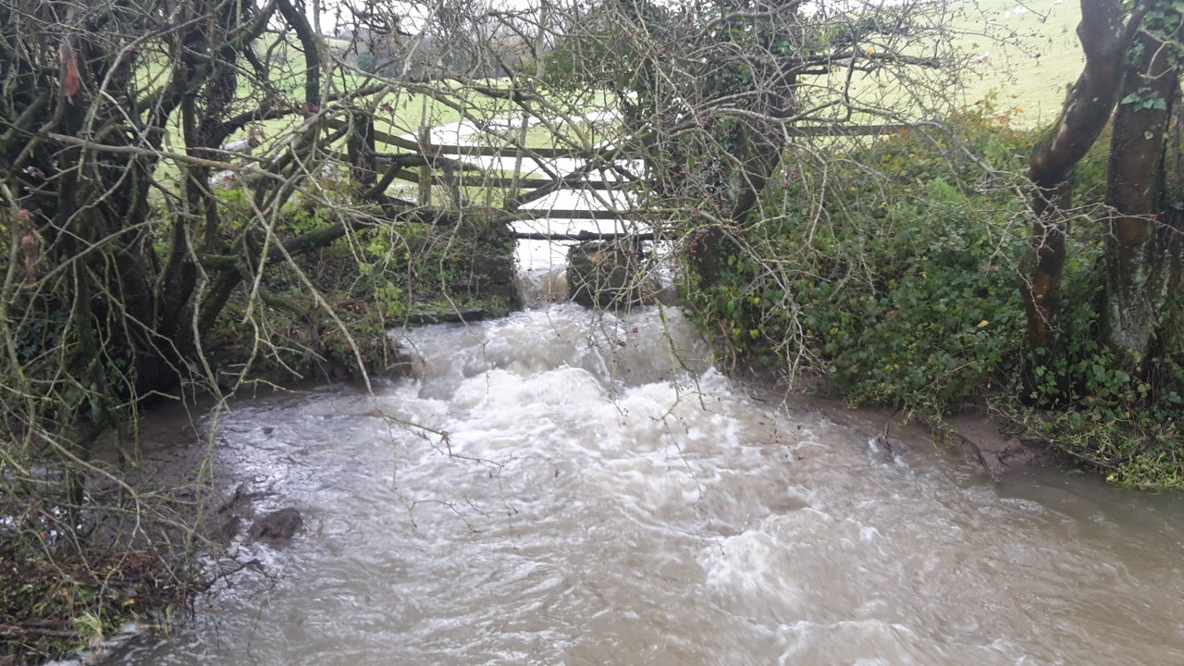
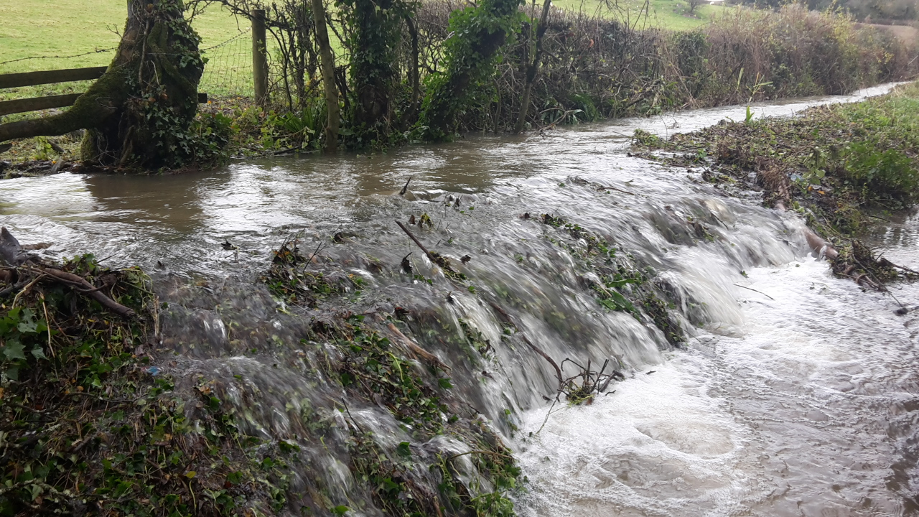

As you can see, the bridge is barely able to cope with the rain, and the river further along has burst its bank and is spilling onto the highway. This small stream feeds into the river Thaw, which already has runoff water from Cowbridge pumped into it. This will pose a significant risk to any agricultural land further downstream from the development, as land continuously flooded will leech any nutrients and become unworkable as well as increasing the risk of traffic accidents as commuters travel along flooded highways. None of this seemed to have been taken into account in the development. A holding area will not be large enough to cater for a winters worth of rainfall without flooding the surrounding area.
The transport links, in particular the roads, are already in poor repair and overcrowded with motorists speeding along straight through St Athan. These additional homes will only make the matter worse as the owners will, understandably, want to travel to work either in Bridgend or Cardiff leaving St Athan as little more than a commuter town with no real sense of community.
That community only has one primary school, and with both Llantwit and Cowbridge comprehensives almost at capacity, where will these children go? There doesn’t seem to be any provision of new schools, leisure facilities or any community areas that a development of this size should include so that the whole community can benefit from them. It simply seems as an easy option for development.
I also raise a concern on the quality of the land in question. This land has in the past produced fields of good crops, with little to no damage from the public right of way (which I’m sure other farms manage to cope with, without developing those fields they cross). Leaving a field unmanaged and unfertilised to downgrade its agricultural benefits seems to be a poor excuse to build on green belt areas.
Finally, we already have huge swaths of the surrounding area purchased by the WDA for the failed RAF St Athan development plan. Wouldn’t it be more prudent to develop these areas if there is a genuine need for new houses in the area? I’m sure it would benefit the public purse once those houses were sold off, as it doesn’t seem likely that the expansion of the base is now going to happen in any sense.
I genuinely hope that you take into account the existing inhabitants of St Athan when reviewing this application, and would urge you to refuse planning permission in an area that does not need more houses but investment in the amenities and needs of those already living here.
I look forward to hearing from you regarding this matter.
Regards,
Mr Bailey

